THE WORLD OF GENERATIVE AI

PROMPT - PLAN - PRODUCE
AI Workflow Basics
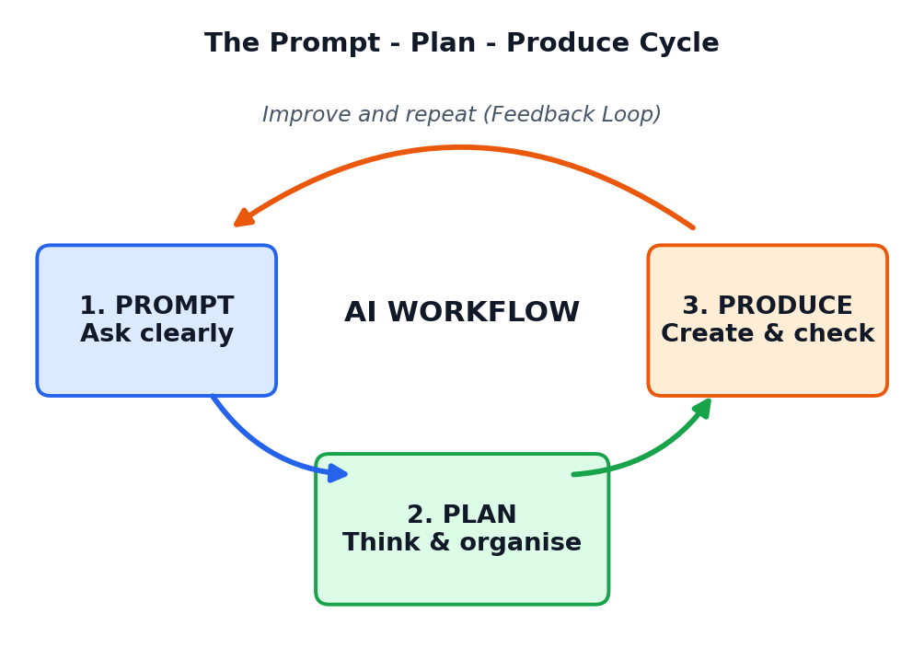
A Student Course Book
Class 12 | One-Month Course
Simple language, clear steps, pictures and practice

About This Book
Read this page first
Welcome to Prompt - Plan - Produce. This book is part of the course The World of Generative AI. It teaches one very useful skill: how to work with Artificial Intelligence (AI) in a clear, step-by-step way so that you get good results and learn something at the same time.
Many students use AI by typing one quick question and copying the answer. Sometimes this works, but often the answer is weak, wrong, or not what the student needed. Professionals do not work like that. They follow a small, repeatable routine called a workflow. This book teaches you a simple three-step workflow that you can use for school projects, exams, hobbies and, later, your career.
Figure 0.1: The three steps of the AI workflow explained in this book

Who is this book for?
This book is written for Class 12 students. You do not need any coding or computer science background. If you can read, write and think about a problem, you can learn everything here. All words are explained in simple English, and difficult words are collected in the Glossary at the end.

What will you be able to do after this course?
- Explain what an AI workflow is and why it is useful.
- Write clear and powerful prompts using the R-T-C-F-C method.
- Break a big task into small steps and make a realistic plan.
- Use AI to produce a first draft, then check, edit and improve it.
- Find mistakes and made-up facts in AI answers.
- Use AI honestly, safely and responsibly.
- Complete a real mini-project from start to finish using the 3P workflow.

How to use this book
- Read one chapter at a time. Every chapter starts with its goals and ends with a short summary.
- Look carefully at each picture. The pictures are not decoration. They explain the idea in a visual way.
- Try every Activity box on your own. You learn AI skills by doing, not only by reading.
- Use the coloured boxes as signposts: Key Idea, Tip, Careful, Example and Activity.
- Finish the practice questions in Chapter 13 and the project in Chapter 12.

What the coloured boxes mean
KEY IDEA
A big idea you should remember for exams and for real life.

TIP
A helpful shortcut or a good habit used by experts.

CAREFUL
A common mistake or risk. Read these slowly.

EXAMPLE
A real sample prompt or situation that shows the idea at work.

ACTIVITY
A small task for you to do yourself, alone or with a friend.

Contents
What you will find in this book
Chapter | Title | What you will learn
1 | What Is an AI Workflow? | Meaning of workflow, everyday examples, why AI needs one
2 | How AI Works: A Simple View | Models, training, next-word guessing, strengths and limits
3 | The Prompt-Plan-Produce Framework | The three steps, how they connect, a first full example
4 | PROMPT: The Anatomy of a Good Prompt | Role, Task, Context, Format, Constraints
5 | PROMPT: Techniques and Common Mistakes | Few-shot, step-by-step, role-play, templates, fixing bad prompts
6 | PLAN: Thinking Before You Create | Goals, task breakdown, tools, time, success checks
7 | PRODUCE: From Draft to Final Work | Generating, reviewing, editing, formatting, sharing
8 | Feedback Loops and Workflow Patterns | Iteration, linear, loop, branch, prompt chaining
9 | Checking AI: Facts, Mistakes and Bias | Hallucinations, verification, bias, human-in-the-loop
10 | Responsible and Ethical Use of AI | Honesty, privacy, copyright, safety, school rules
11 | AI Tools and Future Skills | Types of tools, choosing tools, careers, lifelong learning
12 | Case Studies and Mini-Projects | Five full worked examples and a final project
13 | Practice Questions | MCQs, short answers, long answers, answer key
14 | One-Month Learning Plan | Week-by-week schedule, assessment ideas, self-evaluation
 | Glossary and Quick Revision | Key words and one-page summary

CHAPTER 1

What Is an AI Workflow?
Understanding the idea of a workflow and why AI works best inside one
CHAPTER GOALS
- Explain what a workflow is using everyday examples.
- Describe how AI fits into a workflow.
- Understand why a good process matters more than a single clever question.
- Identify the difference between random AI use and workflow-based AI use.

1.1 The Word 'Workflow'
A workflow is a series of steps that you follow, in a sensible order, to finish a piece of work. The word has two parts: work (the job to be done) and flow (the way it moves from the start to the end). When a job has a clear flow, nothing is forgotten, time is not wasted, and the final result is better.
You already use workflows every day, even if you never call them that. Think about making tea, getting ready for school, or studying for an exam. Each of these has a beginning, a middle and an end, and each step prepares the next step.
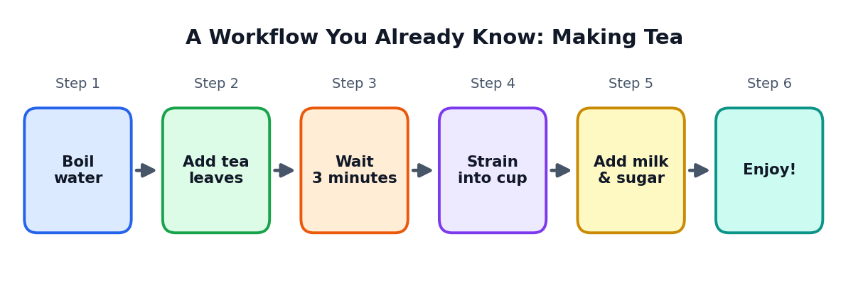
Figure 1.1: Making tea is a simple workflow with six ordered steps
Notice three things about the tea workflow. First, the order matters: if you add milk before boiling the water, the tea will not taste right. Second, each step has a clear purpose. Third, if you repeat the workflow tomorrow you will get a similar result. A good workflow is repeatable.

1.2 More Everyday Workflows
Situation | Workflow steps | What goes wrong without it?
Getting ready for school | Wake up, bathe, dress, pack bag, eat, leave | You forget your books or reach late
Washing clothes | Sort, soak, wash, rinse, dry, fold | Colours mix and clothes get spoiled
Writing a school essay | Choose topic, collect points, outline, write, correct | The essay is messy and has no clear order
Preparing for exams | List chapters, make timetable, revise, test yourself | You run out of time before the exam
Cooking a meal | Plan menu, gather items, cook, taste, serve | Items are missing or food is wrongly cooked

ACTIVITY 1.1: SPOT THE WORKFLOW
Choose any three things you did today (for example, travelling to school, doing homework, helping at home). For each one, write the steps in order. Then answer: which step is the most important? What would happen if you skipped it?

1.3 What Is Artificial Intelligence? (A Quick Reminder)
Artificial Intelligence (AI) means computer systems that can do tasks which normally need human intelligence. These tasks include understanding language, recognising pictures, making decisions and creating new content. In this course we focus on Generative AI. Generative AI creates new things: text, images, music, videos and computer code.
When you type a question into a chatbot and it writes an answer, you are using generative AI. When you describe a picture in words and the computer draws it, that is also generative AI.
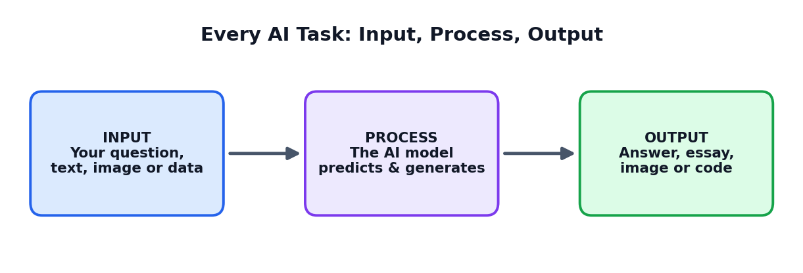
Figure 1.2: Every AI task can be seen as Input, Process, Output
The input is what you give to the AI: a question, a paragraph, a picture or a set of numbers. The process is what happens inside the AI model. The output is what you receive. Your job as a smart user is to control the input and to judge the output, because the quality of the output depends heavily on the quality of the input.

1.4 What Is an AI Workflow?
An AI workflow is a planned series of steps in which a human and an AI tool work together to finish a task. The human decides the goal, gives instructions, checks the results and takes the final decision. The AI helps by creating drafts, ideas, summaries, pictures or code very quickly.
KEY IDEA
An AI workflow is not 'asking AI to do everything'. It is a partnership: the human thinks, plans and judges; the AI generates and speeds up.

Compare the two students below. Both have the same homework: Prepare a short speech on saving water.
Student A (no workflow) | Student B (AI workflow)
Types 'speech on saving water' and copies the answer. | Decides the speech must be 2 minutes long for classmates.
Does not read it fully. Some facts are wrong. | Asks AI for 5 ideas, then picks the best 3.
The speech is too long and sounds unnatural. | Creates an outline, then asks AI for a draft in simple spoken English.
Teacher notices it is not the student's own work. | Checks facts, adds a personal example, practises aloud.
Result: low marks, no learning. | Result: good marks, real learning and confidence.

The difference is not intelligence. The difference is process. Student B followed a workflow.

1.5 Why Do We Need a Workflow for AI?
AI tools are powerful but they have special weaknesses. They do not know your exact situation. They can sound confident even when they are wrong. They may give very general answers if your question is general. A workflow protects you from these problems.

Five benefits of using an AI workflow
- Better quality. Clear steps lead to clear, useful results.
- Saves time. You avoid trying random questions again and again.
- Fewer mistakes. You build checking steps into the process.
- More learning. You think about the task instead of copying blindly.
- Repeatable success. You can reuse your workflow for new tasks.
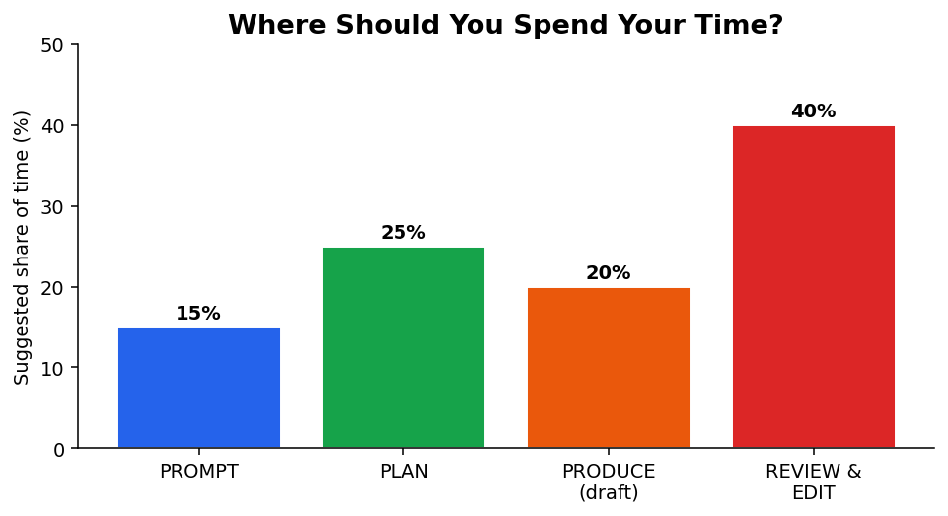
Figure 1.3: A smart AI user spends most time on thinking and checking, not only on generating
Look at Figure 1.3. In a good workflow, the AI draft is only one small part of the time. Planning and reviewing take much more. This is the opposite of what many beginners think!

1.6 A Short Story of How Work Has Changed
Long ago, people wrote everything by hand and calculated everything on paper. Then typewriters, calculators and computers made work faster. Today, AI is the next big tool. Each time a new tool arrived, people who learned to use it well, with a good process, became more successful than those who ignored it or used it carelessly.
The same will be true for AI. In the future, knowing a software name will matter less because tools will keep changing. Knowing how to work with AI, how to ask, plan, check and improve, will stay valuable for many years.
TIP
Tools change quickly, but the 3P workflow in this book works with any AI tool, now or in the future.

1.7 Chapter Summary
- A workflow is a set of ordered steps that moves work from start to finish.
- Generative AI creates new text, images, sound, video and code.
- An AI workflow is a partnership between human thinking and AI speed.
- The human controls the goal, the instructions and the final judgement.
- A good workflow gives better quality, saves time, reduces mistakes and increases learning.
THINK AND WRITE
1. Write your own definition of 'AI workflow' in two sentences.
2. Give two examples from daily life where following steps in order is important.
3. Why is Student B in Section 1.4 likely to learn more than Student A?

CHAPTER 2

How AI Works: A Simple View
A friendly look inside generative AI so that you can use it more wisely
CHAPTER GOALS
- Understand in simple words what an AI model is.
- Learn how language models guess the next word.
- Know what AI is good at and what it is weak at.
- See why this knowledge helps you write better prompts.

2.1 What Is an AI Model?
An AI model is a computer program that has learned patterns from a huge amount of examples. A model that works with language is called a language model. A very large language model is called an LLM (Large Language Model). Chatbots that write answers are usually built on LLMs.
Imagine a student who has read millions of books, websites and articles. That student has not memorised every page, but has become very good at noticing how words and ideas usually fit together. An LLM is a little like that, except it learns by mathematics instead of by understanding in the human sense.

2.2 Training: How a Model Learns
Before you can use an AI model, it must be trained. During training the model looks at a large collection of text and plays a guessing game again and again: given the first part of a sentence, what word should come next? When it guesses wrongly, its internal numbers are adjusted slightly. After billions of such guesses, the model becomes very good at predicting language.
Stage | What happens | Simple comparison
Collecting data | Large amounts of text and other material are gathered | Filling a huge library
Training | The model practises guessing and adjusts itself | A student doing millions of practice questions
Fine-tuning | The model is guided to be helpful and safe | A coach teaching good manners and rules
Using (inference) | You type a prompt and the model replies | Taking the exam: answering new questions

2.3 How the Model Writes an Answer
When you send a prompt, the model does not look up a stored answer like a dictionary. It generates the answer one small piece at a time. At each step it calculates which word (or word-piece) is most likely to come next, based on your prompt and the words already written. Then it repeats the process.
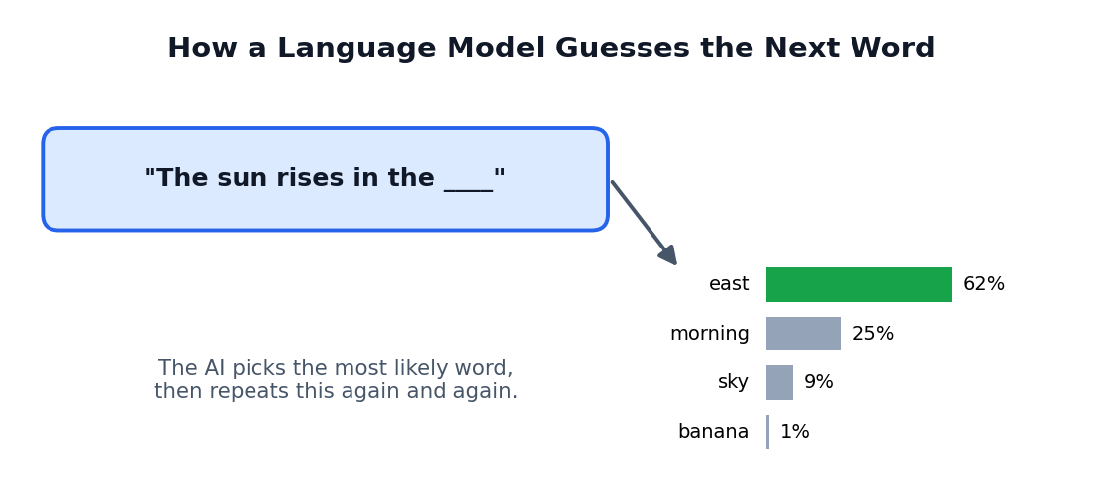
Figure 2.1: The model chooses the most likely next word, step by step
This is why the model is so good at fluent language. It is also the reason it can make mistakes: it chooses what sounds likely, not always what is true.
KEY IDEA
An AI language model predicts likely words. It does not 'know' facts the way a verified encyclopedia does. This is why checking is a required step in every workflow.

2.4 Why Your Prompt Matters So Much
The model only has your prompt (and the earlier conversation) to understand what you want. It cannot read your mind. It does not know your class, your teacher's rules, or your exam pattern unless you say so. A short and vague prompt leaves the model to guess, and it will guess the most common, general answer.
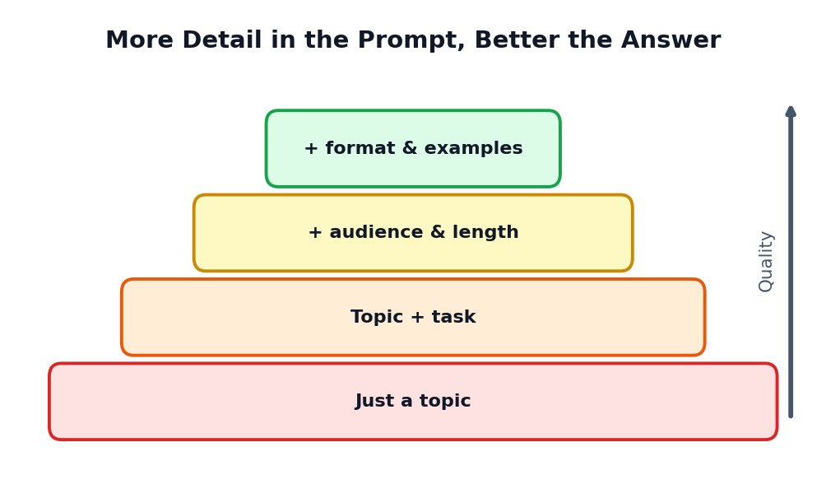
Figure 2.2: As you add more useful details, the quality of the answer rises

2.5 What AI Is Good At
- Speed: it can draft a page of text in seconds.
- Ideas: it can suggest many options for names, topics, titles and approaches.
- Summarising: it can shorten long text into key points.
- Explaining: it can explain a difficult idea at different levels, from simple to advanced.
- Changing style: it can rewrite text to be formal, friendly, short or detailed.
- Translating and rephrasing: it can move between languages and styles.
- Helping with code: it can write, explain and fix simple programs.

2.6 What AI Is Weak At
- Truth checking: it may state wrong facts in a confident tone.
- Latest events: a model may not know recent news unless it has a search feature.
- Your personal situation: it does not know your school rules, your marks or your goals unless you tell it.
- Maths and logic in long steps: it can make slips, so always verify.
- Real feelings and real-life experience: it has no body, no childhood and no personal memories.
- Fairness: it learned from human text, which can contain unfair ideas (bias).
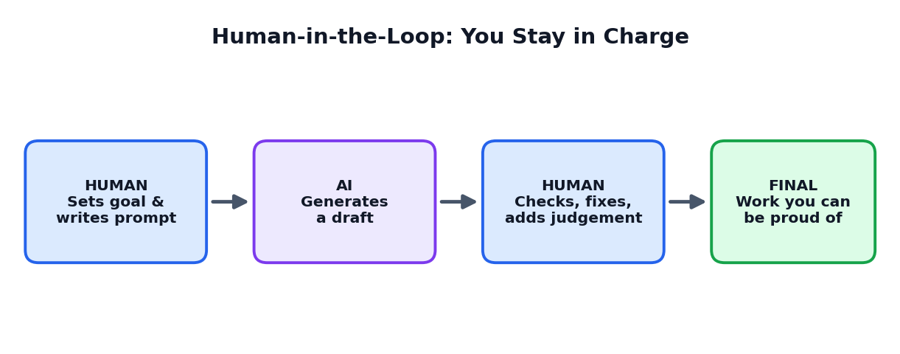
Figure 2.3: Because AI has weaknesses, the human must stay in the loop
CAREFUL
Never submit AI output as your own work without understanding it, checking it and improving it. Your teacher wants to see your learning, not the machine's writing.

2.7 Types of Generative AI
Type | What it creates | Examples of school use
Text AI | Essays, summaries, answers, emails, stories | Explaining a topic, summarising a chapter, practising interviews
Image AI | Pictures, posters, diagrams, logos | Poster ideas, illustrations for a project
Audio AI | Speech, music, transcripts | Turning a lecture into text, practising pronunciation
Video AI | Short clips, subtitles, animations | Explainer videos, subtitles for a presentation
Code AI | Programs, bug fixes, explanations | Learning programming, testing small scripts

2.8 Chapter Summary
- An AI model learns patterns from huge amounts of data during training.
- A language model writes by predicting the next likely word, again and again.
- AI is fast and flexible but can be wrong, outdated or biased.
- More detail in your prompt leads to better answers.
- Humans must stay in the loop to guide, check and decide.
THINK AND WRITE
1. In your own words, explain how a language model produces an answer.
2. List three things AI does well and three things it does badly.
3. Why is it dangerous to trust an AI answer without checking?

CHAPTER 3

The Prompt-Plan-Produce Framework
A simple three-step method for working with AI on any task
CHAPTER GOALS
- Learn the three steps: Prompt, Plan, Produce.
- Understand how the steps connect in a cycle.
- See one complete example from beginning to end.
- Learn why we do not jump straight to producing.

3.1 The Big Picture
The Prompt-Plan-Produce framework, or 3P framework, is an easy way to remember how to work with AI. Instead of a confusing mix of random questions, you move through three clear stages.
Figure 3.1: The 3P cycle. After producing, you review and may return to Prompt
Step | Main question | What you do | Main output
1. PROMPT | What exactly do I want to ask? | Write a clear instruction for the AI | A strong prompt and first ideas
2. PLAN | How will I do this, step by step? | Choose goal, steps, tools, time and quality checks | A written plan or outline
3. PRODUCE | How do I create and improve the result? | Generate, review, edit and finalise | Finished, checked work

3.2 Step 1: PROMPT
A prompt is the message you give to an AI tool. It can be a question, an instruction, or even an example. The Prompt step is about communicating clearly with the AI. You decide who the AI should act as, what task it should do, what background it needs, how the answer should look and what limits it must follow.
In the Prompt step you often use AI for thinking help: getting ideas, asking for options, or asking the AI to ask you questions. This step turns a vague idea in your mind into a clear request.

3.3 Step 2: PLAN
Planning means deciding how you will complete the work before you start producing it. In the Plan step you write down your goal, break the task into smaller steps, decide which tools and resources you need, set a time schedule, and decide how you will know that the work is good. You can also ask AI to help you plan, but the final plan must be your decision.
TIP
Many students skip planning because it feels slow. In reality, five minutes of planning can save an hour of confusion later.

3.4 Step 3: PRODUCE
Producing means creating the actual result: a written answer, a presentation, a poster, a program or a study sheet. The AI usually generates the first draft. Then you review it, check the facts, remove mistakes, add your own ideas, improve the language and finalise the format. Producing is not only generating; it also includes quality control.
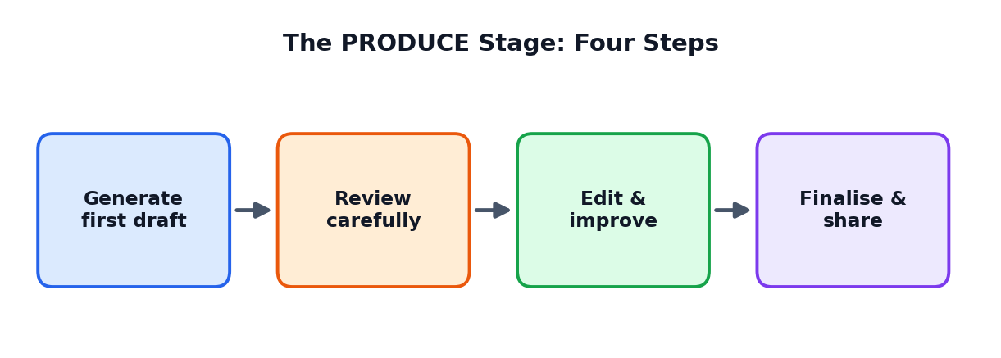
Figure 3.2: Inside the PRODUCE step

3.5 Why Not Just Produce Immediately?
Imagine building a house. Nobody starts by placing bricks. First you decide what kind of house you want (prompt/idea), then an engineer makes a drawing (plan), and only then workers build (produce). If you skip the drawing, you may waste bricks and money. Working with AI is the same: the plan is the drawing, and the final work is the house.
If you skip... | What usually happens
Prompt (clear asking) | The AI gives general, unfocused answers
Plan (thinking first) | Work is disorganised; you forget important parts
Produce checks (review) | Mistakes, copied text and wrong facts reach your final work

3.6 A Complete Example: 'Healthy Eating' Presentation
Meena, a Class 12 student, must give a 3-minute talk on healthy eating habits for teenagers. See how she uses the 3P workflow.
STEP 1: PROMPT
Meena writes: "Act as a school health teacher. I must give a 3-minute talk to Class 12 students on healthy eating. Suggest 5 interesting angles for the talk in one line each."
The AI gives five angles. Meena picks: 'Why skipping breakfast hurts your exam performance.'

STEP 2: PLAN
Meena writes her plan: Goal: persuade classmates to eat breakfast. Time: 3 minutes (about 400 spoken words). Structure: opening question, 3 reasons, one personal story, closing line. Tools: AI for the draft, school textbook and a trusted health website for fact-checking. Quality check: read aloud and time it.

STEP 3: PRODUCE
Meena asks the AI for a 400-word draft in simple spoken English following her structure. She checks every health fact against her textbook, replaces a general story with her own experience, shortens two long sentences, practises aloud, and finishes in 2 minutes 50 seconds.

Notice that Meena used AI at every step but remained the decision-maker. The final talk sounds like her, is accurate and is within the time limit.

3.7 Using 3P for Different Tasks
Task | PROMPT | PLAN | PRODUCE
Writing an essay | Ask for essay ideas and key points | Make outline with intro, 3 body parts, conclusion | Draft each part, edit in own words
Studying a chapter | Ask AI to explain tough parts simply | Make a 5-day revision timetable | Create flashcards and a self-test
Making a poster | Ask for slogans and layout ideas | Choose theme, colours, sections | Create images, add text, check spelling
Learning to code | Ask for a simple example of a loop | Decide the small program to build | Write, run, fix errors, explain the code

3.8 Chapter Summary
- The 3P framework has three steps: Prompt, Plan, Produce.
- Prompt means asking the AI clearly. Plan means thinking before creating. Produce means creating and quality-checking.
- The steps form a cycle; after reviewing you may go back and improve.
- Skipping steps leads to weak, disorganised or incorrect work.
ACTIVITY 3.1: APPLY 3P
Choose a real task you must do this week (a homework, a speech, a revision). Write three lines: what your Prompt will be, what your Plan will contain, and how you will check your Produce stage.

CHAPTER 4

PROMPT: The Anatomy of a Good Prompt
How to write clear instructions that get useful answers
CHAPTER GOALS
- Learn the five parts of a strong prompt (R-T-C-F-C).
- Compare weak and strong prompts.
- Practise building prompts for school tasks.
- Understand how roles change the answer.

4.1 What Is a Prompt?
A prompt is the input you give to a generative AI model. It tells the model what you want. A prompt can be one word, a long paragraph, or even a set of examples and rules. The model reads your prompt carefully and tries to produce the most suitable response.
Prompt engineering is the skill of designing prompts so that AI gives better answers. It sounds technical, but it is mainly clear communication, just like explaining a task to a new classmate.

4.2 Weak Prompt vs Strong Prompt
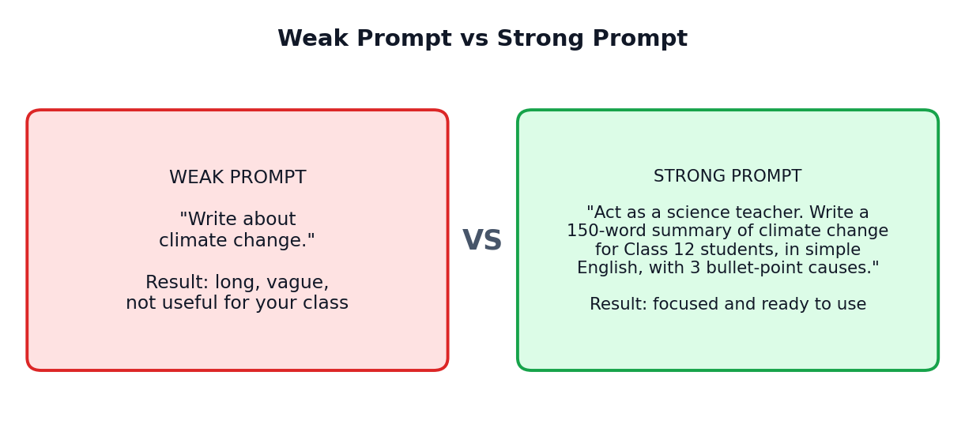
Figure 4.1: The same topic with a weak and a strong prompt
The weak prompt does not say who the answer is for, how long it should be or how it should look. The model must guess all these things. The strong prompt removes the guessing.

4.3 The R-T-C-F-C Method
A strong prompt usually contains five parts. We use the letters R-T-C-F-C to remember them.
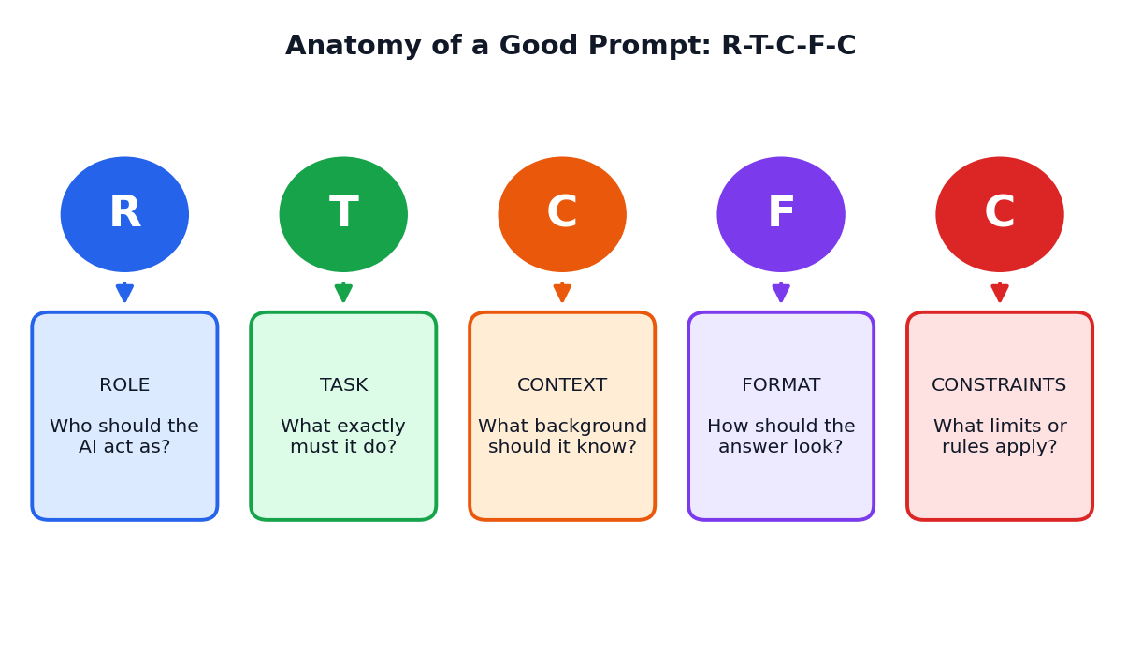
Figure 4.2: The five parts of a strong prompt

R: Role
The role tells the AI who to be. For example: 'Act as a Class 12 Physics teacher', 'Act as a friendly career counsellor', or 'Act as a strict exam evaluator'. A role helps the model choose suitable words, level and tone.
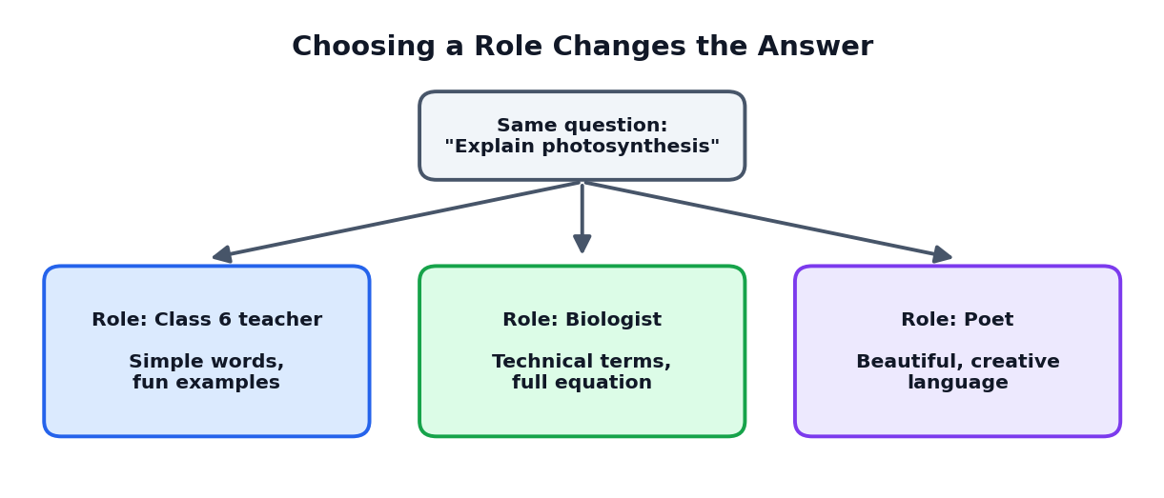
Figure 4.3: The same question gets different answers when the role changes

T: Task
The task is what the AI must do, written with a clear action word: explain, list, compare, summarise, outline, translate, correct, quiz. Avoid vague words like 'talk about' or 'something on'.
Vague task | Clear task
Tell me about electricity | Explain how an electric circuit works in 5 simple steps
Help with my essay | Check my essay paragraph and point out 3 grammar mistakes
Give me questions | Create 5 multiple-choice questions on Chapter 3 of Biology

C: Context
Context is the background information the AI needs: your class, the audience, the topic's purpose, what you already know, or the text you want it to work on. Context makes the answer fit your real situation.

F: Format
Format tells the AI how the answer should look: a table, bullet list, numbered steps, a 100-word paragraph, a short poem, or a dialogue. If you do not ask for a format, the AI chooses one, which may not suit you.

C: Constraints
Constraints are limits and rules: word count, simple language, no technical terms, only use the text I gave, include one example, avoid copying. Constraints keep the answer safe and focused.
REMEMBER R-T-C-F-C
Role: Who should the AI be?
Task: What exactly should it do?
Context: What background should it know?
Format: How should the answer look?
Constraints: What limits must it follow?

4.4 Building a Prompt Step by Step
Let us build a prompt for a Biology revision task.
Part | Your words
Role | Act as a Class 12 Biology teacher.
Task | Explain the process of photosynthesis.
Context | I am a student revising for my board exam and I find the chemical equation confusing.
Format | Use numbered steps and one small table for inputs and outputs.
Constraints | Use simple English, under 200 words, and include a memory trick.

FINAL PROMPT (ALL PARTS JOINED)
"Act as a Class 12 Biology teacher. Explain the process of photosynthesis. I am a student revising for my board exam and I find the chemical equation confusing. Use numbered steps and one small table for inputs and outputs. Use simple English, keep it under 200 words and include a memory trick."

4.5 Prompt Examples for Many School Tasks
Task | Sample prompt
Understand a concept | Act as a Maths tutor. Explain the idea of a derivative to a Class 12 student using a real-life example of speed. Keep it under 150 words.
Summarise notes | Summarise the following notes into 6 bullet points for quick revision: [paste notes]. Use simple words.
Practise questions | Create 5 short-answer questions on 'Federalism' for Class 12 Civics, with a model answer of 3 lines each.
Improve writing | Act as an English teacher. Improve the grammar of my paragraph and explain each change in one line: [paste paragraph].
Plan studies | I have 10 days before my Chemistry exam and 4 chapters to revise. Make a day-wise timetable in a table with 2 hours per day.
Career guidance | Act as a career counsellor. Suggest 5 careers for a student interested in biology and technology, each with one line on required skills.

4.6 Chapter Summary
- A prompt is the instruction you give to an AI. Clear prompts give better results.
- The R-T-C-F-C method covers Role, Task, Context, Format and Constraints.
- Weak prompts leave the AI guessing; strong prompts remove the guessing.
- Changing the role or the format can completely change the answer.
ACTIVITY 4.1: REWRITE THE PROMPT
Take this weak prompt: 'Tell me about computers.' Rewrite it three times for three different situations: (a) a Class 6 child, (b) a Class 12 exam answer, (c) a short speech. Compare how each version changes the type of answer you would expect.

CHAPTER 5

PROMPT: Techniques and Common Mistakes
Moving from basic prompts to powerful prompting skills
CHAPTER GOALS
- Learn five useful prompting techniques.
- Use examples to guide the AI (few-shot prompting).
- Ask for step-by-step thinking.
- Recognise and fix common prompt mistakes.
- Build your own reusable prompt templates.

5.1 The Prompting Ladder
Prompting skill grows like climbing a ladder. You start with simple asking and move up to more advanced techniques that give you more control.
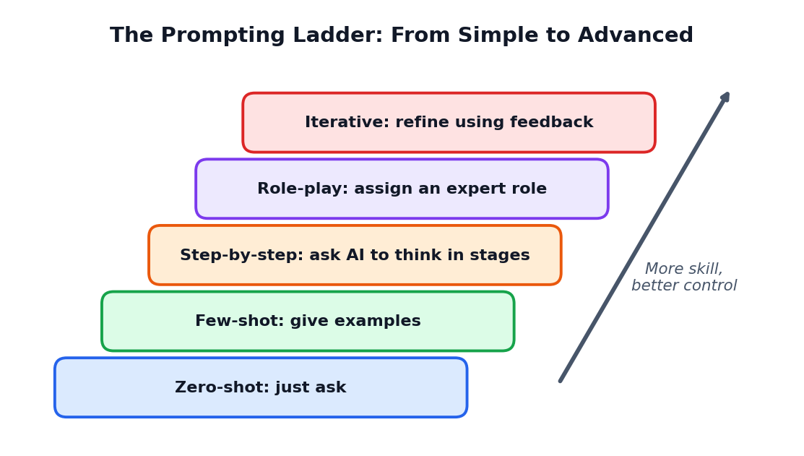
Figure 5.1: Five prompting techniques from simple to advanced

5.2 Technique 1: Zero-Shot Prompting
In zero-shot prompting you simply ask, without giving any example. 'Translate this sentence into Tamil' is a zero-shot prompt. It works well for simple, common tasks. When the task is special or needs a particular style, you need more guidance.

5.3 Technique 2: Few-Shot Prompting (Giving Examples)
In few-shot prompting you show the AI one or more examples of the answer you want. The AI notices the pattern and copies the style. This is very powerful when you want a special format or tone.
FEW-SHOT EXAMPLE
"Convert each fact into a catchy memory line.
Fact: Mitochondria produce energy. Memory line: Mitochondria: the power plant of the cell!
Fact: The heart pumps blood. Memory line: Heart: the body's non-stop pump!
Fact: Chlorophyll absorbs sunlight. Memory line:"
The AI completes the last line in the same fun style.

5.4 Technique 3: Step-by-Step Thinking
For problems that need reasoning, such as maths, logic or planning, you can ask the AI to work step by step and explain each step. This often improves accuracy and also helps you learn the method.
STEP-BY-STEP EXAMPLE
"Solve this problem step by step and explain each step in one line: A train travels 180 km in 3 hours. At the same speed, how far will it travel in 5 hours?"

CAREFUL
Even when the AI shows steps, check the calculation yourself. A neat explanation can still contain an error.

5.5 Technique 4: Role-Play and Perspective
You can assign a role such as examiner, interviewer, debate opponent or customer. Role-play is excellent for practice. For example, ask the AI to act as an interviewer for a college admission and to ask you one question at a time, waiting for your answer before giving feedback.

5.6 Technique 5: Iterative Prompting
Iterative prompting means improving the answer through follow-up messages rather than expecting perfection in one try. You can say: 'Make it shorter', 'Use simpler words', 'Add one example from India', 'Now make a table', 'Explain the second point more'. Each follow-up steers the AI closer to your goal.
Follow-up phrase | What it does
Make it shorter / longer | Changes the length
Explain like I am in Class 8 | Lowers the difficulty
Give two more examples | Adds practical clarity
Turn this into a table | Changes the format
What did you assume? Is anything uncertain? | Reveals weak points to check
Ask me questions before you answer | Lets the AI collect missing context

5.7 The Ten Most Common Prompt Mistakes
Figure 5.2: Detail improves quality. Most mistakes come from missing details
# | Mistake | Better approach
1 | Too vague: 'Write something about AI' | State the exact task, audience and length
2 | No audience mentioned | Say who will read or use the answer
3 | Asking many unrelated things at once | Ask one task at a time, or number them clearly
4 | No format requested | Ask for table, steps, bullets or paragraph
5 | Giving no context or source text | Paste the notes or text you want it to use
6 | Accepting the first answer without review | Review and ask follow-ups
7 | Using unclear words like 'good' or 'nice' | Define the quality: simple, formal, exam-style
8 | Sharing private data | Never type passwords, addresses or ID details
9 | Expecting AI to know latest news | Provide the facts or use a tool with search and verify
10 | Asking AI to do the whole assignment | Use it to learn, plan and draft; write your own final version

5.8 Fixing a Bad Prompt: A Worked Example
Version | Prompt | Problem or improvement
Bad | Give me a speech. | Topic, audience, length all missing
Better | Give me a speech on road safety. | Topic present, but still no length, audience or tone
Good | Write a 2-minute speech on road safety for my school assembly. | Length and audience present
Excellent | Act as a school student speaker. Write a 2-minute assembly speech on road safety for Class 12. Start with a question, include 3 rules and end with a slogan. Use simple spoken English. | All R-T-C-F-C parts included

5.9 Prompt Templates You Can Reuse
A prompt template is a ready-made prompt with blanks that you fill in. Templates save time and help you remember all parts.
TEMPLATE 1: EXPLAIN A TOPIC
Act as a [subject] teacher. Explain [topic] to a [class level] student. Use [number] simple steps and one real-life example. Keep it under [word limit] words.

TEMPLATE 2: CREATE PRACTICE QUESTIONS
Create [number] [type of questions] on [topic] for [class]. Include answers at the end. Difficulty: [easy / medium / hard].

TEMPLATE 3: IMPROVE MY WORK
Act as a [role]. Read my text below and suggest [number] improvements. Do not rewrite everything; explain each suggestion in one line. Text: [paste text]

TEMPLATE 4: MAKE A PLAN
I need to finish [task] by [date]. I can work [hours] hours per day. Make a day-wise plan in a table with a goal for each day.

5.10 Chapter Summary
- Zero-shot means no examples; few-shot means giving examples.
- Step-by-step prompts help with reasoning problems.
- Role-play is a great way to practise interviews, debates and speaking.
- Iterative prompting improves answers through follow-up messages.
- Templates help you write complete prompts quickly.
ACTIVITY 5.1: BUILD YOUR TEMPLATE NOTEBOOK
Create a small notebook page with four templates you will use most (for example: explain, quiz me, improve my writing, make a plan). Test each one with a real topic this week and improve it.

CHAPTER 6

PLAN: Thinking Before You Create
How to turn an idea into a clear, realistic plan
CHAPTER GOALS
- Understand why planning is the most powerful step.
- Set a clear and measurable goal.
- Break big tasks into small steps.
- Choose tools, resources and time.
- Decide success checks before you begin.
- Use AI as a planning assistant without losing control.

6.1 What Is Planning?
Planning means deciding what you will do, in what order, with which tools and by when, before you start doing it. A plan is like a map. Without a map you may still reach somewhere, but you may take a long and tiring route, or get lost.
In AI workflows, planning has an extra importance. AI can produce huge amounts of content in seconds. If you do not know what you need, you will drown in content that does not fit. A plan keeps you in control of the direction.
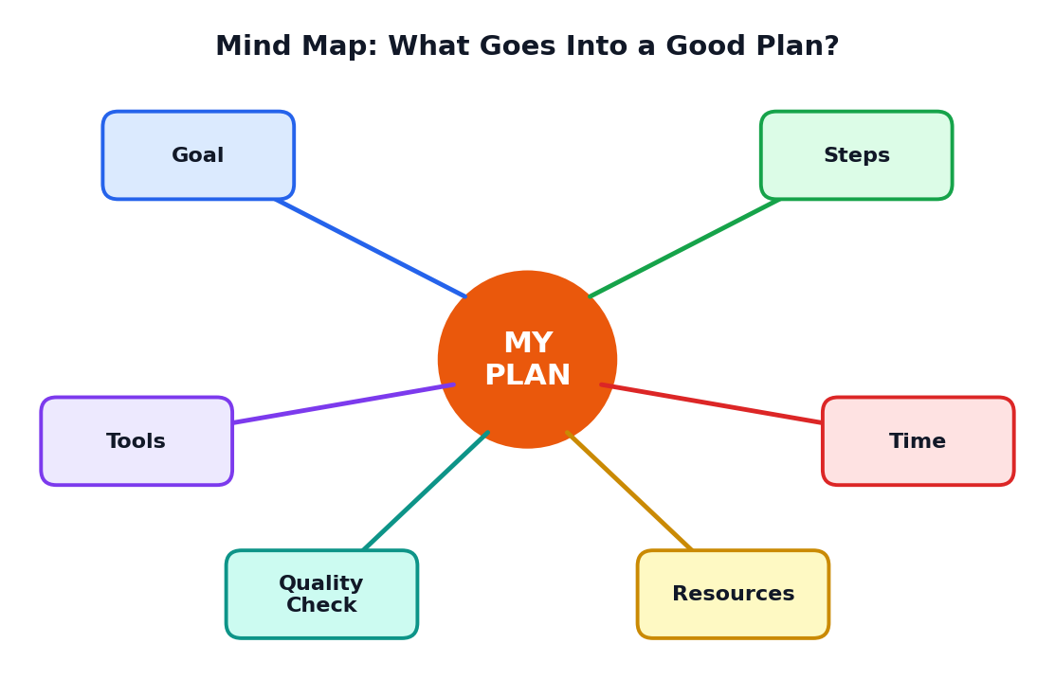
Figure 6.1: A good plan has six parts: goal, steps, tools, time, resources and a quality check

6.2 Part 1: Define Your Goal
A goal tells you what 'finished' looks like. Weak goals are unclear: 'do my project'. Strong goals are specific and measurable: 'Make an 8-slide presentation on solar energy that I can explain in 5 minutes by Friday.'

The SMART goal check
Letter | Meaning | Question to ask | Example
S | Specific | What exactly will I make? | A 5-minute talk on water saving
M | Measurable | How will I know it is done? | 400 words, 3 main points
A | Achievable | Can I really do it? | I have 3 days and enough information
R | Relevant | Does it match the assignment? | Teacher asked for a speech on environment
T | Time-bound | By when? | Ready by Thursday evening

6.3 Part 2: Break the Task into Steps
Big tasks feel scary because they are unclear. When you break a big task into small steps, each step becomes simple. This idea is called task breakdown or decomposition.
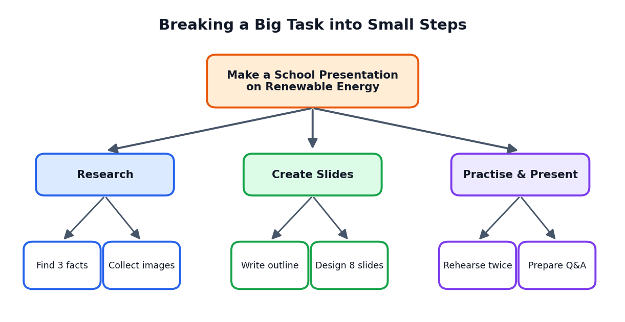
Figure 6.2: Breaking a presentation task into main parts and small steps

How to break a task down
- Write the final goal at the top.
- List the 3 to 5 main parts needed to reach it.
- Break each main part into small actions that take 10 to 30 minutes.
- Put the actions in a sensible order.
- Mark which actions AI can help with and which only you can do.
PROMPT TO GET PLANNING HELP
"I must prepare a 5-minute presentation on renewable energy for my Class 12 class in 4 days. Break this into small steps I can finish in 30 minutes each. Present it as a numbered list."

6.4 Part 3: Choose Tools and Resources
Ask: what will I need? Tools can include a chatbot, a presentation program, a search engine, a notebook, or a calculator. Resources include your textbook, teacher's notes, reliable websites, and your own experiences. Choosing early prevents last-minute stress.
Need | Possible tool or resource | Why
Ideas and drafts | Text AI chatbot | Fast brainstorming and first drafts
Correct facts | Textbook, official websites | Reliable and checked information
Pictures | Image AI or free image libraries | Visuals for slides and posters
Final document | Word processor or slides program | Clean formatting and printing
Practice | Friends, mirror, voice recorder | Builds confidence and timing

6.5 Which Parts Should AI Do? Which Should You Do?
Not every step should be given to AI. A smart planner decides what to delegate.
Good for AI to help | Better for you to do yourself
Brainstorming ideas and titles | Choosing the final idea that fits your goal
Creating a first outline | Deciding what is important to your teacher and audience
Simplifying difficult text | Understanding the concept deeply
Checking grammar | Adding personal examples and opinions
Making practice questions | Answering the practice questions without help first

6.6 Part 4: Set the Time Plan
Time planning makes your work realistic. Estimate how long each step will take, add some extra time for problems, and write a deadline for each step. A simple timeline chart can help you see the whole project.
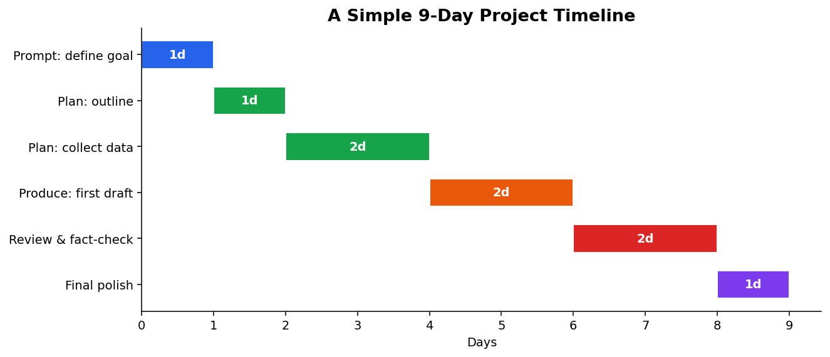
Figure 6.3: A 9-day project timeline with overlapping stages
TIP
Always add a 'buffer' of about 20 percent extra time. Tasks nearly always take longer than expected, especially when you must review and correct AI output.

6.7 Part 5: Decide How You Will Check Quality
Before you start, decide what 'good' means. Write 3 to 5 checks. For a presentation these may be: all facts verified, fits within 5 minutes, simple language, each slide has one main idea, no copied text. These are called success criteria.
ACTIVITY 6.1: SUCCESS CRITERIA
Pick a school task. Write five success criteria for it, each starting with 'I will know it is good when...'. Keep them measurable, such as 'it is under 300 words' or 'I can explain every point without reading'.

6.8 Part 6: Think About Risks
What could go wrong? The AI might give wrong facts. The internet might not work. You might run out of time. A good planner thinks about risks and prepares a backup.
Possible risk | Backup plan
AI gives incorrect information | Verify with textbook and one more trusted source
AI tool is not available | Keep notes and outline offline; use another tool or manual method
Draft sounds robotic | Rewrite in own words, add personal example
Running out of time | Finish the core part first; keep extras optional

6.9 Using AI as a Planning Partner
AI can be an excellent planning assistant. You can ask it to suggest steps, create a checklist, estimate time, or find missing parts of your plan. But remember: you are the project manager. The AI offers suggestions; you decide what is realistic for your life, your school and your skills.
PLANNING CONVERSATION
You: "I need to prepare a science exhibition model on rainwater harvesting in 10 days. I can work 1 hour on weekdays and 3 hours on Sunday. Suggest a day-wise plan with a review day at the end."
AI: (gives a schedule)
You: "Day 3 is too heavy. Move the research task to Day 2 and give Day 3 only a light task."
AI: (updates the schedule)

6.10 A Ready-to-Use Planning Sheet
Planning item | My answer
Task name
Final goal (SMART)
Main steps (3 to 5)
Tools and resources
Deadline for each step
What AI will help with
What I will do myself
Success criteria
Risks and backup

6.11 Chapter Summary
- Planning decides the direction and keeps you in control of AI.
- A strong plan has a goal, steps, tools, time, quality checks and risk thinking.
- SMART goals are specific, measurable, achievable, relevant and time-bound.
- Task breakdown makes big work easy.
- AI can help you plan, but you must make the final decisions.
CHAPTER 7

PRODUCE: From Draft to Final Work
How to create, check, improve and finish your work with AI
CHAPTER GOALS
- Understand the four stages of production.
- Generate a useful first draft with AI.
- Review and edit like a careful reader.
- Add your own voice and original thinking.
- Finalise, format and share your work responsibly.

7.1 What Does 'Produce' Mean?
To produce is to turn your plan into a real, finished result. In many school tasks this is an essay, a presentation, a chart, a poster or a program. With AI, producing has four stages: generate, review, edit and finalise.
Figure 7.1: Four stages of producing

7.2 Stage 1: Generate the First Draft
Use your plan and your best prompt to ask the AI for a first version. It is called a draft because it is not final. Think of the AI draft as raw material, like clay that you will shape.

Tips for generating drafts
- Generate one part at a time (for example one section), not the entire project at once.
- Paste your outline into the prompt so that the AI follows your structure.
- Ask for two different versions if you are unsure of the style.
- Tell the AI what to avoid, such as complicated words or long sentences.
DRAFT PROMPT USING THE PLAN
"Using the outline below, write section 2 only (about 120 words) for a Class 12 audience in simple English. Outline: [paste outline]. Do not add facts that are not in my outline."

7.3 Stage 2: Review Like an Examiner
Now put on the thinking cap of a strict examiner. Read the draft slowly and ask these questions.
Review question | What to look for
Is it correct? | Wrong facts, dates, numbers, names, spelling of terms
Is it complete? | Missing points from your plan or the teacher's instructions
Is it relevant? | Extra material that does not belong
Is it clear? | Long, confusing or repeated sentences
Is it fair and respectful? | Biased words, stereotypes, harmful ideas
Is it original? | Does it sound like me? Is any part copied?

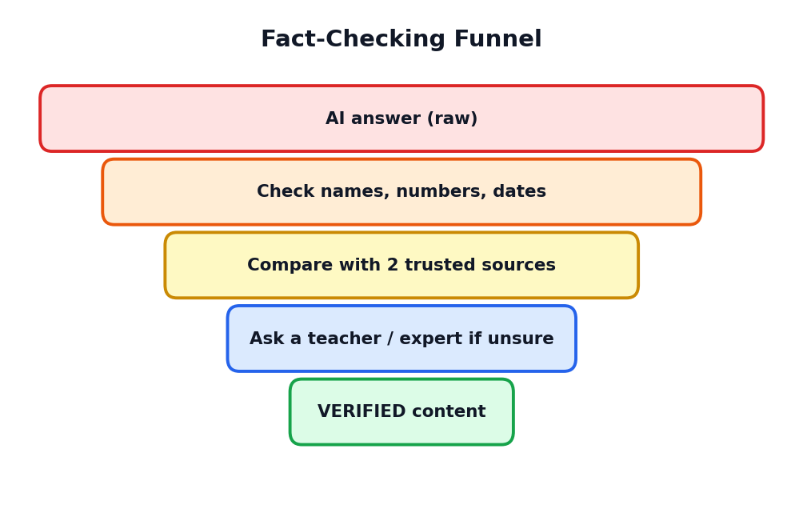
Figure 7.2: Reviewing is like a funnel that filters AI output into verified content

7.4 Stage 3: Edit and Improve
Editing is where your human skills shine. You correct mistakes, remove unnecessary parts, add your own examples, and change the language so that it sounds like you. You can use AI again for editing help, but with careful instructions.

Editing checklist
- Correct all factual mistakes using trusted sources.
- Shorten long sentences and remove repeated ideas.
- Replace general statements with specific examples, ideally from your own life or country.
- Add your own opinion or reflection where suitable.
- Check grammar, spelling and punctuation.
- Make sure the work follows the teacher's format and word limit.
TIP: THE READ-ALOUD TEST
Read your final text aloud. If a sentence feels awkward or you stumble, it probably needs fixing. If you could not explain a sentence to a friend, you do not understand it well enough yet.

7.5 Stage 4: Finalise and Share
Finalising means preparing the work in its final shape: correct headings, neat layout, readable fonts, good pictures, page numbers and a list of sources. If you used AI for help, follow your school's rules about declaring it. Honesty builds trust.
SAMPLE AI-USE NOTE
"I used an AI tool to brainstorm ideas and to check grammar in my draft. I verified all facts using my textbook and the sources listed below, and I wrote the final text myself."

7.6 Before-and-After Example
AI first draft | After human review and editing
Water is very important. Water should be saved by everyone. There are many ways to save water. | At my home, we reuse washing-machine water to clean the floor. Small habits like this can save hundreds of litres each month.
The Earth has 71 percent water so there is no problem. | Although about 71 percent of Earth is covered by water, only a small part is fresh and usable, so saving water matters. (Checked in geography textbook, Class 10.)

The edited version is more specific, correct and personal. It also shows thinking, which teachers value.

7.7 Producing Different Types of Work
Output type | Generate with AI | Human checks and edits
Essay | Outline, sample paragraphs, vocabulary ideas | Facts, own arguments, conclusion in own words
Presentation | Slide titles, bullet points, speaker notes | Simplify slides, add visuals, practise delivery
Poster | Slogans, layout ideas, images | Spelling, colours, balance, meaning
Study notes | Summaries, flashcards, mnemonics | Accuracy against textbook, personal examples
Code project | Starter code, error explanations | Run, test, understand each line
Data report | Chart ideas, summary of patterns | Check numbers, label charts, draw conclusions

7.8 Version Control: Keep Your Drafts
Save each important version of your work with a clear name, such as Speech_v1_AI-draft, Speech_v2_edited, Speech_final. If you make a mistake or change your mind, you can go back. Keeping versions also shows how your work developed, which is useful if a teacher asks about your process.

7.9 Chapter Summary
- Producing has four stages: generate, review, edit and finalise.
- An AI draft is raw material, not a finished product.
- Review for correctness, completeness, clarity, fairness and originality.
- Editing adds your own voice, examples and thinking.
- Finalise neatly and be honest about how you used AI.
ACTIVITY 7.1: EDIT AN AI DRAFT
Ask an AI tool for a 100-word paragraph on any school topic. Then: (a) highlight any claim you cannot verify, (b) check it using your textbook, (c) rewrite the paragraph in your own words with one personal example. Write two lines on what you learned.

CHAPTER 8

Feedback Loops and Workflow Patterns
How good results come from trying, checking and improving
CHAPTER GOALS
- Understand why the first answer is rarely the best.
- Use the feedback loop to improve your work.
- Learn three basic workflow patterns: linear, loop and branch.
- Use prompt chaining for bigger tasks.
- Get a simple idea of AI agents and automation.

8.1 The First Answer Is Only the Beginning
Many beginners think that if the first answer is not perfect, the AI tool has failed. Experts think differently. They know that good work comes from iteration, which means repeating a cycle of trying, checking and improving. Even professional writers, designers and engineers make many drafts.

8.2 The Feedback Loop
A feedback loop is a process where the result of one step is checked and used to improve the next try. In AI workflows the loop has four moves: write or refine the prompt, receive the answer, check its quality, and decide whether to improve it.
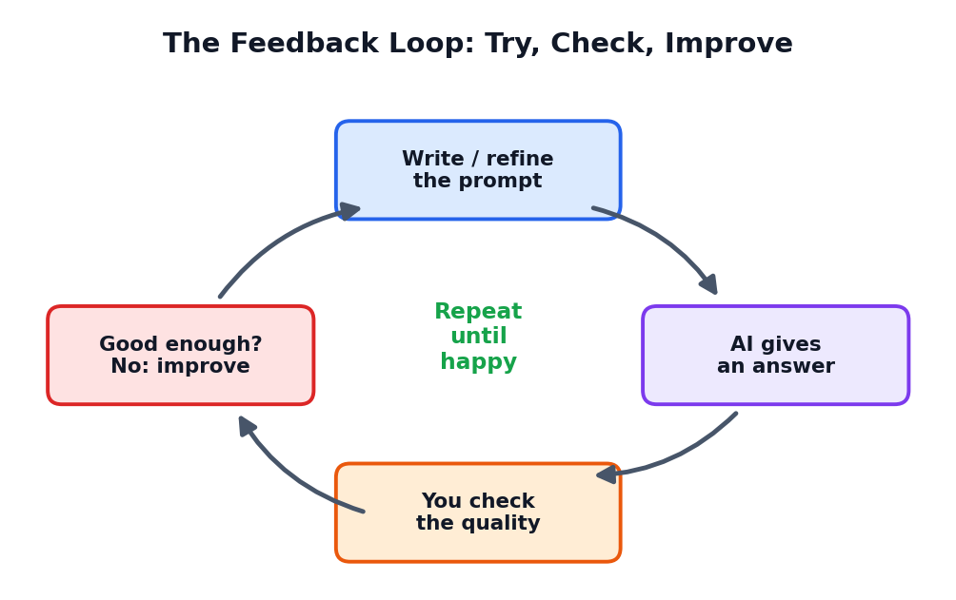
Figure 8.1: The feedback loop. Repeat until the result meets your success criteria

How to give useful feedback to AI
Feedback should be specific. Compare these two messages.
Weak feedback | Strong feedback
This is bad. Do it again. | The second paragraph is too long. Shorten it to 2 sentences and add one example from daily life.
Make it better. | Use simpler words suitable for Class 9 and remove the technical term 'photolysis'.
I don't like it. | The tone is too formal. Make it friendly and add a question at the start.

TIP
Point to the exact part that needs change and say exactly how you want it changed. Think like a teacher giving clear remarks on a notebook.

8.3 When Should You Stop Iterating?
You can keep improving forever, so you need a stopping rule. Stop when your work meets the success criteria that you wrote in the Plan stage. If all your checks are passed, the work is good enough. Do not waste time on tiny changes that do not matter.
ACTIVITY 8.1: THREE ROUNDS
Ask an AI to write a 60-word description of your school. Do three rounds of feedback, each time changing one thing (tone, length, detail). Write what changed after each round and which version you prefer.

8.4 Workflow Pattern 1: Linear
In a linear workflow the steps happen one after another, in a straight line. Step 1 leads to step 2, step 2 to step 3 and so on. This pattern is best for simple, predictable tasks.
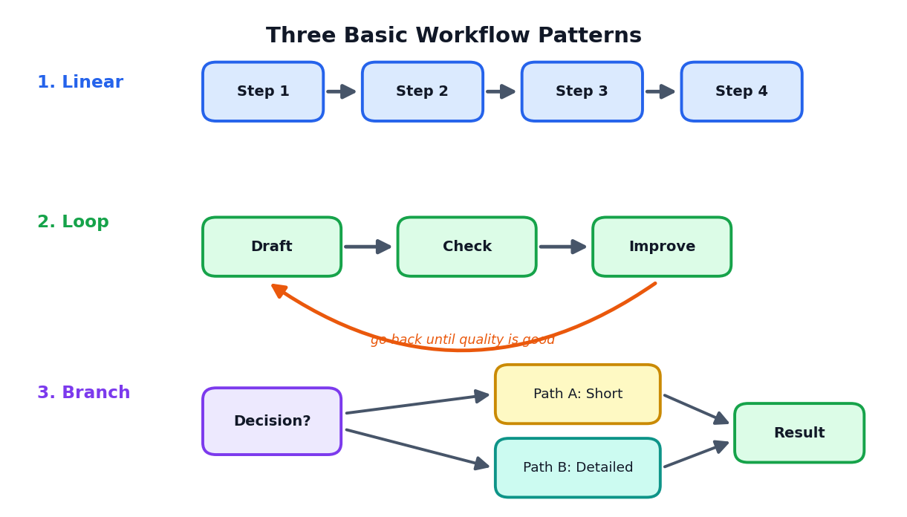
Figure 8.2: Three basic workflow patterns
Example of a linear workflow: Choose topic, collect points, write outline, write draft, final copy.

8.5 Workflow Pattern 2: Loop
In a loop workflow some steps repeat until a condition is met. For instance, you draft, check and improve again and again until the quality is acceptable. Loops are common when working with AI because the first draft often needs improvements.

8.6 Workflow Pattern 3: Branch
In a branch workflow you reach a decision point and take different paths depending on the answer. For example: Is the topic new to me? If yes, ask AI for a simple explanation first. If no, go directly to practice questions. Branches make a workflow flexible.
Pattern | Shape | Best used when | Study example
Linear | A to B to C | Steps are fixed | Making a neat copy of notes
Loop | Draft, check, improve, repeat | Quality needs several rounds | Improving an essay
Branch | If this then that | Choices depend on a situation | Choosing revision method by difficulty

8.7 Prompt Chaining
Some tasks are too big for one prompt. Prompt chaining means breaking a task into a series of smaller prompts, where the output of one prompt becomes the input for the next. Each prompt does one small job well.
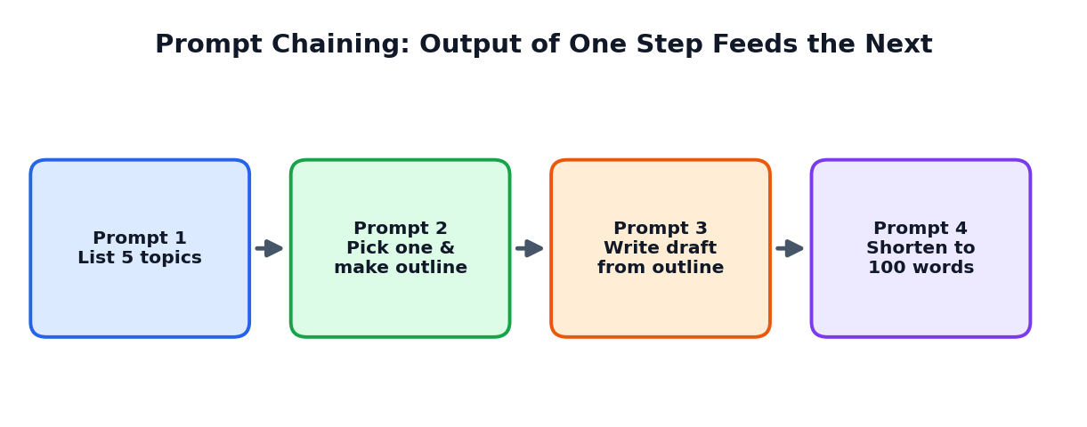
Figure 8.3: A chain of four prompts to build a short piece of writing
PROMPT CHAIN FOR A SPEECH
1. "Give me 5 topic ideas for a 2-minute speech on technology and school."
2. "I choose idea 3. Make a 4-point outline."
3. "Write a 200-word draft following this outline in simple spoken English."
4. "Shorten the draft to 150 words and add a strong closing line."

Why chaining works
- Each step is small and easy for the AI to do well.
- You can check each result before moving on.
- If something goes wrong, you only repeat one step, not everything.
- It matches how people naturally work: plan, then draft, then polish.

8.8 A Peek at Automation and AI Agents
As AI tools advance, some can follow multi-step instructions with less human guidance. These are sometimes called AI agents. An agent can, for example, search for information, summarise it, and prepare a report as a series of connected actions. In offices, workflows can be automated so that routine tasks run by themselves.
However, the same rule holds as always: the more power the tool has, the more important human supervision becomes. Before you let any tool act for you, understand what it will do, check what it produced, and keep control of important decisions.
CAREFUL
Never allow an AI tool to send messages, make purchases or change important files without your approval. Always review before you confirm.

8.9 Chapter Summary
- Iteration means improving work through repeated cycles of trying and checking.
- Good feedback is specific and tells the AI exactly what to change.
- Stop when your success criteria are met.
- Three patterns: linear (straight line), loop (repeat), branch (decision).
- Prompt chaining breaks a big task into small prompts connected one after another.
CHAPTER 9

Checking AI: Facts, Mistakes and Bias
Becoming a careful, critical and trustworthy AI user
CHAPTER GOALS
- Know what AI hallucination is and why it happens.
- Learn a simple method to verify AI answers.
- Understand bias in AI and how to reduce its effect.
- See why the human stays in the loop for important decisions.

9.1 AI Can Sound Right and Still Be Wrong
One of the most important facts about generative AI is this: it can write confident, well-organised sentences that are partly or fully wrong. This happens because the model is designed to produce likely-sounding language, not to check truth the way a scientist would.

9.2 What Is a Hallucination?
In AI, a hallucination is an answer that sounds believable but contains false or invented information. The model may invent a book title, a quotation, a date, a website or even a scientific 'fact'. It does this without any intention to lie; it is simply completing patterns.
Type of hallucination | Example (imaginary) | How to catch it
Invented fact | 'The Himalayas formed in the year 1500.' | Check a trusted textbook or encyclopedia
Fake source | A book or article that does not exist | Search the exact title; verify the author
Wrong number | A calculation or statistic that is off | Recalculate; find the original data
Fake quote | A famous person 'said' something they never said | Search for the quote in reliable collections
Outdated information | Old rules or old records presented as current | Check official, recent sources

9.3 Why Do Hallucinations Happen?
- The model predicts likely words; it does not look up verified facts by default.
- Its training data may have gaps, errors or old information.
- Vague or unusual questions push the model to guess.
- The model often tries to be helpful even when it does not know.

9.4 The Verification Method
Here is a simple routine to check important AI content. Think of it as the V-E-R-I-F-Y routine.
Letter | Action | How
V | Value the risky parts | Mark names, numbers, dates, quotes and 'always/never' claims
E | Examine with a trusted source | Textbook, official site, reputed encyclopedia
R | Recheck with a second source | Two matching sources are better than one
I | Inspect the logic | Does the reasoning make sense step by step?
F | Fix the errors | Correct the text or remove the claim
Y | Yield sources | Note where you verified the information

Figure 9.1: Filtering AI output through checking steps
TIP: ASK THE AI TO HELP YOU CHECK
You can ask: "Which parts of your answer are you least sure about? Which facts should I verify?" This does not replace your own checking, but it helps you decide where to look first.

9.5 Trusted Sources: How to Judge
More trustworthy | Be careful with
School textbooks and teacher notes | Anonymous posts and random forums
Government and official organisation websites | Websites full of advertisements and strong claims
Established encyclopedias and academic publications | Social media forwards with no source
Pages that show the author, date and references | Pages with no author or date

9.6 Understanding Bias in AI
Bias means an unfair leaning towards or against certain people or ideas. AI learns from text, images and data created by humans. If that material contains unfair ideas or gives too much attention to some groups and too little to others, the AI may repeat these patterns.

Examples of bias
- An image tool that mostly shows men when asked for 'doctor' and mostly women for 'nurse'.
- A writing tool that assumes certain jobs belong to certain communities.
- A tool that works better in one language or region than another because of the training data.

What you can do about bias
- Notice it: read AI output for unfair assumptions.
- Ask clearly for balanced, inclusive or multiple viewpoints.
- Compare answers from different sources.
- Edit unfair wording out of your final work.
- Speak to a teacher if you see harmful output.
PROMPT TO REDUCE BIAS
"Give me a balanced explanation of this topic with at least two different viewpoints. Avoid stereotypes about any gender, community, religion or region."

9.7 Human-in-the-Loop
Human-in-the-loop means that a person stays involved at the important points of the process: setting the goal, reviewing the output and making the final decision. This is especially important for health, safety, law, money and school assessment, where mistakes can cause real harm.
Figure 9.2: Human, AI, then human again. Humans begin and end the process
Low-risk tasks | High-risk tasks (need extra care)
Brainstorming party themes | Medical or health advice
Making a fun quiz for friends | Legal or financial decisions
Rephrasing a casual message | Facts in exam answers or official documents
Suggesting a poster colour scheme | Anything involving other people's private data

9.8 Spotting AI-Generated Content
It is also useful to recognise when content may have been made by AI. Signs include an overly smooth style with little personality, repeated phrases, missing specific details, and facts that cannot be traced to a source. No sign is certain, so never accuse anyone based only on style. The best habit is to ask for sources and understanding.

9.9 Chapter Summary
- Hallucination means confident but false or invented output.
- Use the V-E-R-I-F-Y routine to verify names, numbers, dates and quotes.
- Prefer trusted sources such as textbooks and official websites.
- Bias comes from human data; notice it, ask for balance and edit it out.
- Keep a human in the loop, especially for high-risk matters.
ACTIVITY 9.1: HALLUCINATION HUNT
Ask an AI tool for 5 facts about a topic you know well (such as your own school or town, or a chapter you recently studied). Mark each fact as correct, partly correct or incorrect after checking. Count the percentage that were fully correct and discuss the result with your class.

CHAPTER 10

Responsible and Ethical Use of AI
Using powerful tools with honesty, care and respect
CHAPTER GOALS
- Understand what ethics means in the AI context.
- Learn the five pillars of responsible AI use.
- Protect your privacy and the privacy of others.
- Respect copyright and academic honesty.
- Create your own personal code of AI use.

10.1 What Is Ethics?
Ethics means thinking about what is right and wrong and choosing to do what is right. Every powerful tool needs ethics. A knife can cut vegetables or cause harm; it depends on the user. AI is the same. It can help you learn, or it can help you cheat. The tool does not decide; you do.
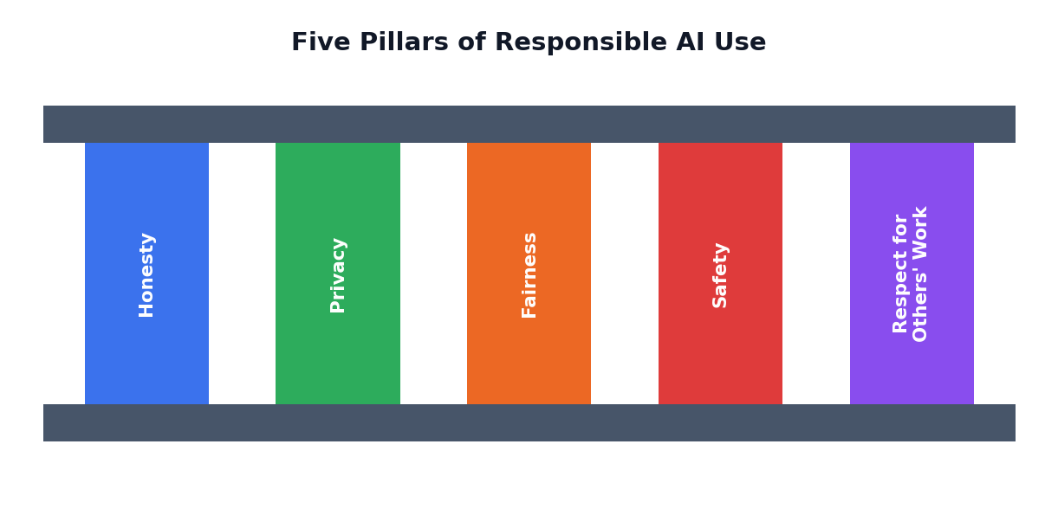
Figure 10.1: Five pillars that support responsible AI use

10.2 Pillar 1: Honesty
Be honest about your work. Do not present AI-written text as your own writing when your teacher expects original work. If AI helped, say how it helped, according to your school's rules. Honesty also means not using AI to create false news, fake messages or fake evidence.
CAREFUL
Submitting AI-generated work as entirely your own can count as academic dishonesty. It also steals your chance to learn. Always follow your school or board rules.

10.3 Pillar 2: Privacy
Many AI tools store or process what you type. Therefore do not share private or sensitive information. This includes passwords, bank details, ID numbers, home address, phone number, private photos and personal secrets of yourself or others.
Safe to share | Do NOT share
A general topic from your textbook | Passwords and OTP codes
Your own essay paragraph without personal details | Photos of friends without their permission
Questions about how to study | Your full name with address and school details
A public fact you want explained | Anyone's private messages or health information

TIP: REPLACE REAL NAMES
If you must paste a text that has names, replace them with labels such as 'Student A' or 'Friend B' before sharing.

10.4 Pillar 3: Fairness
Fairness means not harming or insulting people because of their gender, religion, caste, community, language, region, disability or economic background. Check AI output for stereotypes, and never use AI to bully, mock or spread hate.

10.5 Pillar 4: Safety
Use AI in ways that keep you and others safe. Do not follow dangerous instructions. For health problems, emotional trouble or legal issues, speak to a qualified person such as a doctor, counsellor, parent or teacher. AI can give general information, but it is not a replacement for professional help.
CAREFUL
If you feel very sad, scared or unsafe, please talk to a trusted adult or a counsellor immediately. A chatbot is not a substitute for real human support.

10.6 Pillar 5: Respect for Others' Work
Writers, artists, musicians and programmers own their creations through copyright. Copying large parts of someone's work without permission is wrong, even if an AI helps you do it. When you use ideas or facts from other sources, give credit. When you use AI-generated images or text in public, check the tool's terms of use.

Good habits for credit
- Write the source name and author for facts you have borrowed.
- Do not copy text word for word; explain ideas in your own words.
- Use pictures that are free to use, or those you created, and follow licence rules.
- Never claim another person's creation as your own.

10.7 Deepfakes and Misinformation
Generative AI can create realistic fake images, voices and videos, called deepfakes. These can be used to cheat, defame or frighten people. As a responsible user you must never create or share fake content that harms others. When you see shocking content online, pause, check the source and look for confirmation from reliable news or official channels before forwarding.
Before sharing, ask yourself | Why it matters
Who created this? | Unknown sources may be unreliable
Is there a trusted source that confirms it? | Fake content spreads quickly
Could it hurt someone if it is false? | Protecting others is part of ethics
Am I sharing it only because it is shocking? | Strong emotions are often used to mislead

10.8 Using AI for Learning, Not Just for Answers
The goal of school is to build your mind. If AI does all the thinking, your own skills stay weak. Use AI like a tutor, not like a substitute student.
Learning-friendly use | Learning-damaging use
Ask AI to explain a topic in a simpler way | Ask AI to write the whole assignment and submit it
Ask for practice questions, then try before checking | Copy answers without attempting
Request feedback on your own draft | Replace your draft entirely with AI text
Ask 'why?' and 'how?' to understand deeply | Accept the first answer without understanding

10.9 Your Personal Code of AI Use
ACTIVITY 10.1: WRITE YOUR CODE
Write a personal code of AI use with at least five rules. Example rules:
- I will use AI to learn, not to avoid learning.
- I will verify important facts before using them.
- I will never share private information with AI tools.
- I will tell my teacher when AI has helped me.
- I will never use AI to hurt, cheat or mislead anyone.
Sign your code and keep it in your notebook.

10.10 Chapter Summary
- Ethics means choosing what is right when using powerful tools.
- Five pillars: Honesty, Privacy, Fairness, Safety and Respect for Others' Work.
- Do not share private data; avoid creating or spreading fake content.
- Use AI as a tutor that helps you learn, not as a shortcut that replaces your learning.
CHAPTER 11

AI Tools and Future Skills
Choosing tools wisely and preparing for the future
CHAPTER GOALS
- Know the main types of AI tools and what each one does.
- Learn how to choose a tool for a task.
- Understand how AI is changing careers.
- Identify the skills that will stay valuable.

11.1 The Landscape of AI Tools
There are many AI tools, and new ones appear constantly. Instead of memorising names, learn the types of tools and the kind of work each does.
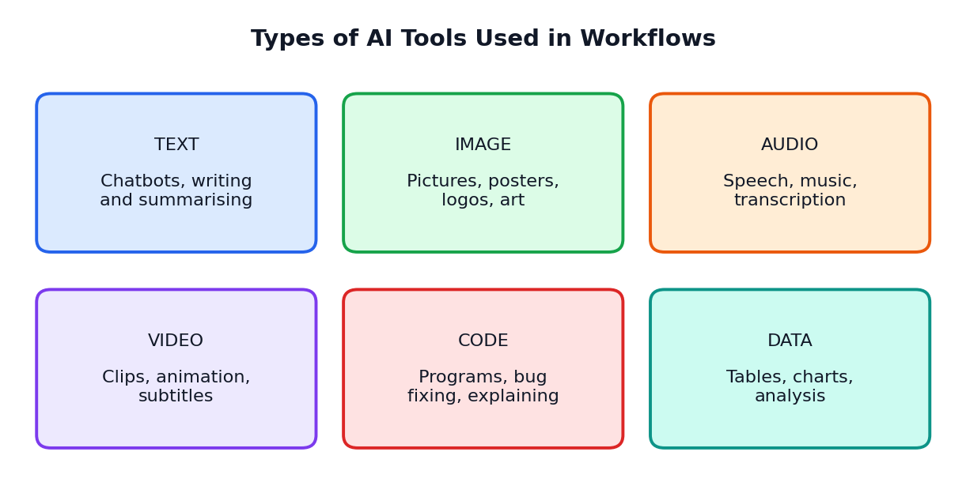
Figure 11.1: Six common types of AI tools
Type | Typical jobs | Class 12 uses
Text | Chat, writing, summarising, translating | Concept explanations, revision notes, grammar help
Image | Drawing, editing, designing | Posters, project illustrations (check licence rules)
Audio | Speech to text, text to speech, music | Lecture notes from recordings, pronunciation practice
Video | Short clips, subtitles | Presentation clips, language subtitles
Code | Writing and fixing code | Learning programming, debugging practice
Data | Cleaning, charts, analysis | Science and commerce project data

11.2 How to Choose the Right Tool
- Define the task first. Do you need text, pictures, numbers or code?
- Check the purpose. Is it allowed for school work? Does your teacher permit it?
- Think about privacy. Does the tool ask for personal data? Is it safe for your age?
- Test with a small sample. Try a small example before trusting it with an important task.
- Compare results. If it matters, try two tools and compare their answers.
- Check the cost. Many tools have free versions; do not pay without permission of your parents.
TIP
A tool's name does not matter as much as your workflow. If you master the 3P method, you can use any tool well.

11.3 AI in the World of Work
AI is already changing how many jobs are done. In healthcare it helps with reading scans and organising records. In farming it helps with weather and crop planning. In business it helps with customer service and data analysis. In education it supports personalised learning. In media it helps with editing and translation.
This does not mean that humans are no longer needed. Instead, many jobs will change: routine parts may be done by AI, while humans focus on judgement, creativity, care for people and responsibility.
Field | How AI may help | What humans still do best
Medicine | Spotting patterns in scans, summarising records | Caring for patients, final diagnosis and ethics
Teaching | Creating practice material, personalising exercises | Inspiring, mentoring, understanding each child
Engineering | Testing designs, writing code drafts | Creative design, safety decisions
Business | Analysing data, drafting reports | Strategy, relationships, leadership
Agriculture | Weather and soil analysis | Local knowledge, decisions on the field
Arts and media | Generating drafts and variations | Original vision, emotion, storytelling

11.4 Skills That Will Stay Valuable
- Critical thinking: questioning and checking information.
- Communication: writing and speaking clearly, including clear prompts.
- Creativity: coming up with original ideas that AI cannot feel or experience.
- Planning and problem solving: breaking big problems into steps.
- Ethics and responsibility: doing the right thing when no one is watching.
- Learning how to learn: staying curious as tools change.
- Teamwork and empathy: working well with people.

11.5 Staying Curious: A Lifelong Habit
AI will keep changing. The details you learn today may look different in five years, but the habits stay useful: ask clear questions, plan before acting, check facts, improve through feedback and act ethically. If you keep these habits, you will adapt to any new tool.

11.6 Chapter Summary
- AI tools come in types: text, image, audio, video, code and data.
- Choose a tool by the task, the rules, privacy and test results.
- AI changes jobs more than it removes the need for human skills.
- Critical thinking, communication, creativity, planning and ethics are future-proof skills.
ACTIVITY 11.1: CAREER INTERVIEW
Choose a career you are interested in. Ask a person who works in that field (or research with trusted sources) how AI is changing their work. Write a half-page report and share it with your class.

CHAPTER 12

Case Studies and Mini-Projects
Five complete worked examples of the 3P workflow, plus your final project
CHAPTER GOALS
- See the 3P workflow used on five different real-life school tasks.
- Learn from sample prompts, plans and review notes.
- Complete a final mini-project of your own.

In this chapter you will follow five students as they use the Prompt-Plan-Produce workflow. Read each case carefully, notice what decisions the students make, and think about what you would do differently.
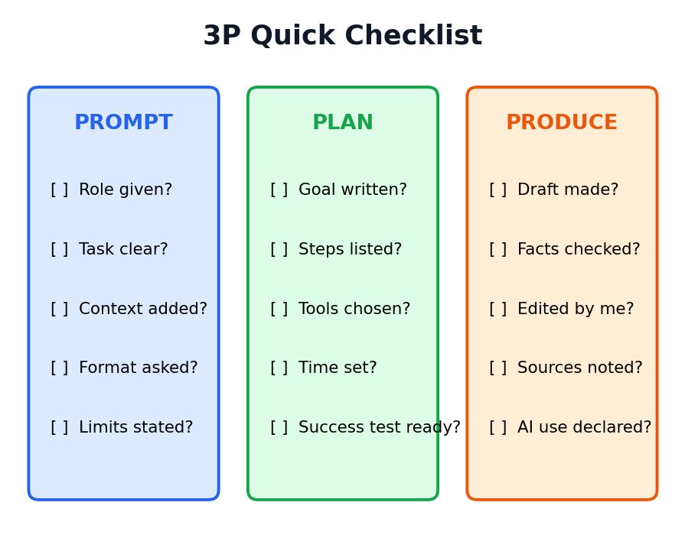
Figure 12.1: The 3P quick checklist. Use it for every case and project

Case Study 1: Writing an Essay on Technology and Teenagers
Student: Karthik, Class 12. Task: a 400-word essay titled 'Technology and Teenagers: Friend or Foe?' due in five days.
PROMPT
Karthik first asks: "Act as an English teacher. I must write a 400-word essay on 'Technology and Teenagers: Friend or Foe?'. Give me 6 key points, 3 positive and 3 negative, in one line each. Use simple English."
He also asks: "Ask me three questions that will help me add my own opinion." The AI asks about his daily phone use, a time when technology helped him, and a time it distracted him.

PLAN
- Goal: 400 words, 5 paragraphs (introduction, 2 positive, 2 negative, conclusion with opinion).
- Time: Day 1 outline, Day 2 draft, Day 3 facts and edit, Day 4 final copy, Day 5 spare.
- Tools: AI for ideas and grammar feedback; school library and news websites for facts.
- Success check: every paragraph has one clear point and one example; 380 to 420 words; own opinion in conclusion.

PRODUCE
Karthik writes the first draft himself using his outline, then asks the AI: "Read my draft and give 5 suggestions to improve clarity. Do not rewrite it." He accepts three suggestions, rejects two, verifies a statistic that the AI mentioned (it was outdated, so he removes it), and adds a personal story about using online classes.

WHAT WE LEARN
Karthik used AI as a coach, not as a ghost-writer. His essay stays original, accurate and personal, and he learns to write better.

Case Study 2: Exam Revision Plan for Chemistry
Student: Divya, Class 12. Task: revise 6 chapters of Chemistry in 12 days before the exam. She finds organic reactions the hardest.
PROMPT
"I have 12 days to revise 6 Chemistry chapters. Chapter 4 and 5 (organic reactions) are hardest for me. I can study 2 hours on weekdays and 4 hours on weekends. Make a day-wise table with the chapter, the activity, and a short self-test for each day. Keep one day free for a full revision test."

PLAN
Divya reviews the AI timetable and adjusts it. She moves a hard chapter earlier in the day when she feels fresh, adds half-hour breaks, and sets success criteria: finish every chapter at least once, make a one-page summary per chapter, and score above 70 percent in the final self-test.

PRODUCE
Divya asks the AI to create 10 practice questions per chapter, tries to answer them without help, and only then checks the answers using her textbook. For a reaction mechanism that the AI explained in a confusing way, she checks her teacher's notes and asks the AI to explain it again with a simple analogy.

WHAT WE LEARN
Planning with AI is powerful, but you must personalise the plan. Practice questions are best used before looking at the answers.

Case Study 3: Science Exhibition Project on Rainwater Harvesting
Students: a team of three. Task: build a working model and a poster explaining rainwater harvesting for the school science exhibition in ten days.
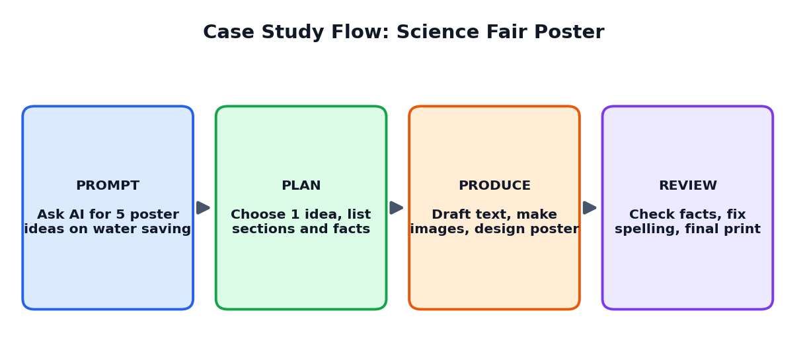
Figure 12.2: The 3P workflow for a science project
PROMPT
"Act as a science project mentor. We are three Class 12 students. Suggest 5 simple model ideas that show rainwater harvesting, using low-cost materials, that we can finish in 10 days. Give a short list of materials for each."

PLAN
- Choose idea: a model house with roof, pipe and storage container with a filter layer.
- Roles: one student builds, one writes poster text, one collects facts and prepares the speech.
- Schedule: Days 1-2 research and materials; Days 3-6 build; Days 7-8 poster; Day 9 practice; Day 10 spare time.
- Success check: model works when water is poured; poster text under 150 words; each member can explain the project.

PRODUCE
They ask AI for draft poster text and slogan ideas. They compare water statistics with official sources and correct two mistakes. They design the poster by hand with their own drawings, practise explaining the model to each other, and write a short note on how AI helped them.

WHAT WE LEARN
AI can speed up idea generation and writing, but hands-on skills, teamwork and fact-checking remain human jobs.

Case Study 4: Career Exploration and Mock Interview
Student: Priya, Class 12. Task: decide between two career options and practise for a college interview.
PROMPT (CAREER EXPLORATION)
"Act as a career counsellor. I like biology and also enjoy using technology. Suggest 5 possible career paths, and for each give: what the job involves, subjects needed, and one skill I should start building now. Use a table."

PROMPT (MOCK INTERVIEW)
"Act as an interviewer for a college admission. Ask me one question at a time about why I chose this course. Wait for my answer. After each answer, give feedback in two lines: one strength and one improvement. Start now."

PLAN
Priya lists the five careers, checks each one on official college and government career websites, and talks to her teacher and a relative who works in healthcare. She then decides on two options to explore further.

PRODUCE
She practises six mock interview questions, records her spoken answers, and notes that she often says 'actually' too many times. After three rounds her answers become clearer. She writes final answers in her own words, using her real experiences.

WHAT WE LEARN
Role-play prompts are excellent for practice. But career decisions should be based on verified information and conversations with real people.

Case Study 5: Learning a Programming Idea
Student: Arun, Class 12. Task: understand 'loops' in programming and write a small program that prints the multiplication table of a number.
PROMPT
"Act as a patient programming tutor. Explain what a loop is using a real-life example, then show a very small example that prints numbers 1 to 5. Explain each line. I am a beginner."

PLAN
Arun plans: (1) understand the loop idea, (2) type the example himself, (3) change it to print a multiplication table, (4) test with three different numbers, (5) write a comment explaining each line.

PRODUCE
Arun does not copy and paste. He types the example by hand, runs it, and then tries to make the table program on his own. When he gets an error, he pastes the error message and asks: "Explain what this error means in simple words and give a hint, but do not give me the full answer yet." After fixing it, he explains the program aloud to a friend.

WHAT WE LEARN
Asking for hints rather than full solutions builds real skill. Testing and explaining your own work proves that you understand it.

Your Final Mini-Project: My 3P Portfolio
Now it is your turn. Choose one of the project options below and complete it using the 3P workflow. You will submit a short portfolio showing your prompts, plan, drafts and final work.
Option | Project idea | Final product
A | A 3-minute talk on a topic of social importance | Speech text and delivery
B | A revision guide for one chapter of any subject | Two-page study sheet with 10 quiz questions
C | A poster or infographic on a science or environment topic | Printed or digital poster
D | A career report on one profession | One-page report and 5-question interview
E | A small program or spreadsheet that solves a school problem | Working file and explanation

Portfolio contents
- Page 1: Title, goal and success criteria (from your Plan).
- Page 2: Your best three prompts and a one-line note on why each worked or failed.
- Page 3: Your plan: steps, tools, timeline and risks.
- Page 4: Draft versus final version, with notes on what you changed and why.
- Page 5: Verification table: facts checked and sources used.
- Page 6: Reflection: what AI did well, what you did yourself, and what you learned.

Assessment rubric
Skill | 4 (Excellent) | 3 (Good) | 2 (Fair) | 1 (Needs work)
Prompt quality | All R-T-C-F-C parts clear | Most parts present | Some parts missing | Vague prompts
Planning | Clear goal, steps, time and checks | Good plan with minor gaps | Basic plan | No real plan
Production and editing | Excellent edit; own voice | Good edit | Little editing | Mostly copied from AI
Verification | All key facts checked with sources | Most checked | Few checked | None checked
Ethics and honesty | AI use clearly declared | Declared but incomplete | Unclear | Not declared

SELF-REFLECTION QUESTIONS
1. Which of the three steps (Prompt, Plan, Produce) was the most difficult for you? Why?
2. What is one thing you will do differently next time?
3. How did you check that your final work was correct and original?
4. Would you recommend this workflow to a friend? Give two reasons.

CHAPTER 13

Practice Questions
Test yourself and prepare for classroom assessments
HOW TO USE THIS CHAPTER
Try each question yourself first. Then check the answer key at the end of the chapter. Review the sections for any question you missed.

Part A: Multiple Choice Questions (1 mark each)
Choose the correct option for each question.
Q1. A workflow is best described as (a) a single clever question (b) a series of ordered steps to finish work (c) a type of computer virus (d) a kind of keyboard
Q2. Generative AI mainly (a) creates new content such as text and images (b) only stores old files (c) only repairs computers (d) only plays music
Q3. In an AI workflow, the human (a) only presses a button (b) sets the goal, checks the output and decides (c) must never review the answer (d) should hide the use of AI
Q4. The three steps of the framework are (a) Print, Paste, Post (b) Prompt, Plan, Produce (c) Plan, Pause, Play (d) Prompt, Pay, Publish
Q5. A prompt is (a) the screen of a computer (b) the instruction or input given to an AI (c) a type of virus (d) the battery of a device
Q6. In R-T-C-F-C, the letter F stands for (a) Fact (b) Fun (c) Format (d) Final
Q7. Giving the AI a role such as 'Act as a Biology teacher' mainly helps to (a) change the language of the computer (b) adjust the tone, level and style of the answer (c) make the AI faster (d) delete old answers
Q8. Which of these is the strongest prompt? (a) Tell me about water. (b) Write something on water. (c) Act as a science teacher and write a 120-word explanation of the water cycle for Class 9 in simple English with 4 steps. (d) Water please.
Q9. Few-shot prompting means (a) asking with no words (b) giving one or more examples in the prompt (c) asking only three questions (d) shutting down the AI
Q10. Asking the AI to 'work step by step' is most useful for (a) reasoning and calculation problems (b) choosing a font (c) turning off the internet (d) saving a file
Q11. Iterative prompting means (a) using a prompt once only (b) improving the answer through follow-up messages (c) deleting the chat (d) using only one word
Q12. Which is a common prompt mistake? (a) Stating the audience (b) Giving context (c) Being too vague (d) Asking for a format
Q13. The main purpose of the Plan step is to (a) avoid thinking (b) decide how to complete the task before creating it (c) make the AI faster (d) hide mistakes
Q14. In SMART goals, the letter M stands for (a) Memorable (b) Measurable (c) Magical (d) Mandatory
Q15. Task breakdown means (a) dividing a big task into small steps (b) breaking a computer (c) deleting a task (d) making a task bigger
Q16. Success criteria are best decided (a) after submitting the work (b) before or during planning (c) never (d) only by the AI
Q17. A buffer in time planning is (a) extra time added for problems (b) a type of tool (c) a printer part (d) a mistake
Q18. In the Produce step, the first AI answer is usually called a (a) final copy (b) draft (c) certificate (d) password
Q19. Which stage comes right after generating a draft? (a) Review (b) Submission without checking (c) Deleting the plan (d) Sleeping
Q20. The read-aloud test helps you to (a) find awkward sentences and unclear ideas (b) save electricity (c) increase the AI speed (d) delete files
Q21. A feedback loop is (a) a cable (b) a cycle of trying, checking and improving (c) a type of paper (d) a single yes or no
Q22. Which feedback is most useful? (a) Bad. Redo. (b) Make it better. (c) Shorten paragraph 2 to two sentences and add one daily-life example. (d) I don't like it.
Q23. Prompt chaining means (a) connecting several small prompts where each uses the previous output (b) using one huge prompt only (c) chaining computers with iron chains (d) copying the same prompt many times
Q24. A hallucination in AI is (a) a dream of the user (b) a confident but false or invented answer (c) a very fast answer (d) a type of image
Q25. The best way to deal with a doubtful AI fact is to (a) trust it because it sounds confident (b) verify it with trusted sources (c) share it quickly (d) ignore the topic
Q26. Bias in AI usually comes from (a) the colour of the screen (b) unfair patterns in human-created training data (c) the speed of the internet (d) the size of the keyboard
Q27. Human-in-the-loop is especially important for (a) high-risk matters such as health, law and exams (b) choosing a wallpaper (c) naming a pet (d) picking a game
Q28. Which information is safe to share with an AI tool? (a) Your password (b) Your bank card number (c) A general textbook topic (d) Your OTP code
Q29. Copying someone's work without credit is (a) good practice (b) a violation of respect for others' work (c) always allowed (d) a type of editing
Q30. Which is a learning-friendly use of AI? (a) Submitting AI text as your own (b) Trying practice questions first, then checking answers (c) Skipping all study (d) Copying answers blindly

Part B: True or False
No. | Statement | Your answer
1 | An AI language model always tells the truth.
2 | A good plan includes a goal, steps, tools, time and a quality check.
3 | The first AI answer must always be accepted.
4 | Few-shot prompting uses examples inside the prompt.
5 | Sharing your passwords with a chatbot is safe.
6 | Human judgement is needed at the beginning and end of an AI workflow.
7 | Prompt chaining uses the output of one prompt as the input of the next.
8 | Hallucinations never happen in modern AI.
9 | Planning helps you stay in control of AI.
10 | You should declare AI use when your school rules require it.

Part C: Fill in the Blanks
- A series of ordered steps to finish a task is called a ______.
- The three steps of the framework are Prompt, ______ and Produce.
- In R-T-C-F-C, the first letter R stands for ______.
- A confident but false answer from an AI is called a ______.
- Improving an answer through repeated trying and checking is called ______.
- Breaking a big task into small steps is called task ______.
- A ______ is the first version of your work that is not yet final.
- Using the output of one prompt as the input of the next is called prompt ______.
- Unfair leaning in AI results because of the data is called ______.
- A human who stays involved in AI decisions is called a human-in-the-______.

Part D: Short Answer Questions (2 to 3 marks each)
- Define 'workflow' and give one example from daily life.
- What is generative AI? Name three kinds of content it can create.
- Explain Input, Process and Output in an AI task.
- List the three steps of the Prompt-Plan-Produce framework and write one line about each.
- Write the full form and meaning of each letter in R-T-C-F-C.
- Why does adding context to a prompt improve the answer?
- What is few-shot prompting? Give a short example.
- Name any four common prompt mistakes.
- What are SMART goals? Explain with an example.
- Why should we break a big task into smaller steps?
- What are success criteria? Why are they decided early?
- List the four stages of the Produce step.
- What is a hallucination in AI? Give two ways to detect it.
- What is bias in AI? Give one example.
- Mention any four rules for responsible AI use.

Part E: Long Answer Questions (8 to 10 marks)
- Explain the Prompt-Plan-Produce framework with a neat diagram and one full example. (10 marks)
- Describe the R-T-C-F-C method of writing prompts. Convert the weak prompt 'Tell me about the heart' into a strong prompt. (8 marks)
- Discuss the importance of planning in an AI workflow. Explain the six parts of a good plan. (8 marks)
- Explain the four stages of the Produce step and show how a human improves an AI draft. (8 marks)
- What is a feedback loop? Explain linear, loop and branch workflow patterns with examples. (8 marks)
- Explain hallucination and bias in AI. Describe the V-E-R-I-F-Y routine for checking information. (8 marks)
- Describe the five pillars of responsible AI use with suitable examples. (10 marks)
- Prepare a complete 3P workflow for the task: 'Create a 5-minute presentation on the importance of sleep for students.' (10 marks)

Part F: Application and Thinking Questions
- A friend submits an AI-written essay without reading it. Write four problems that may happen and what advice you would give.
- You asked an AI for the year of an important event and it gave a date that looks wrong. Explain the exact steps you would take.
- Rewrite this prompt to make it stronger: 'Make a quiz.' Use all five parts of R-T-C-F-C.
- Draw a mind map of a good plan for preparing a school science exhibition project.
- Your class is deciding rules for using AI in homework. Suggest five fair rules and explain why each is useful.

Answer Key

Part A: MCQ answers
Q | Ans | Q | Ans | Q | Ans | Q | Ans | Q | Ans
1 | b | 7 | b | 13 | b | 19 | a | 25 | b
2 | a | 8 | c | 14 | b | 20 | a | 26 | b
3 | b | 9 | b | 15 | a | 21 | b | 27 | a
4 | b | 10 | a | 16 | b | 22 | c | 28 | c
5 | b | 11 | b | 17 | a | 23 | a | 29 | b
6 | c | 12 | c | 18 | b | 24 | b | 30 | b

Part B: True or False answers
No. | Answer
1 | False
2 | True
3 | False
4 | True
5 | False
6 | True
7 | True
8 | False
9 | True
10 | True

Part C: Fill in the blanks answers
1. workflow 2. Plan 3. Role 4. hallucination 5. iteration (or feedback loop) 6. breakdown (or decomposition) 7. draft 8. chaining 9. bias 10. loop

Parts D, E and F: Guidance
- For short answers, write 3 to 5 clear lines using key terms from the chapter and give one example.
- For long answers, use headings, a labelled diagram or table where possible, and end with a one-line conclusion.
- For application questions, there is more than one good answer. Marks are given for clear reasoning, correct use of the 3P ideas and honest, ethical thinking.
MODEL ANSWER: PART F, QUESTION 3
"Act as a Class 12 Biology teacher. Create 5 multiple-choice questions on the topic 'Human Digestive System' for revision. I am preparing for my board exam and need medium-level questions. Use the format: question, four options, and the correct answer at the end. Keep language simple and do not repeat any question."

CHAPTER 14

One-Month Learning Plan
A week-by-week schedule for teachers and students
This chapter gives a suggested four-week plan for learning the Prompt-Plan-Produce workflow. The plan assumes about 4 to 5 sessions per week, each of 45 to 60 minutes. Teachers can adjust it according to their timetable.
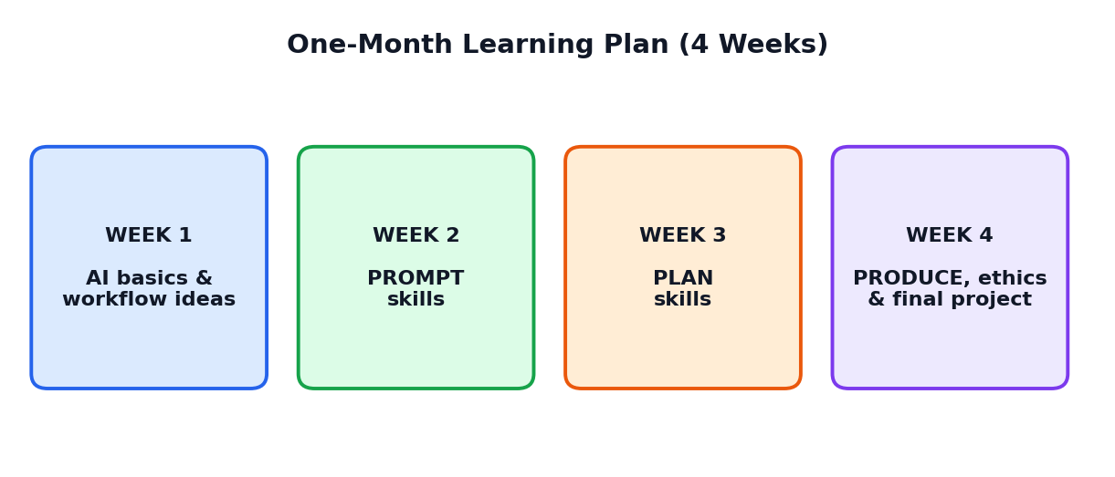
Figure 14.1: The four-week learning journey

14.1 Weekly Plan
Week | Theme | Chapters | Main activities
1 | AI basics and workflow thinking | 1, 2, 3 | Spot everyday workflows; learn how AI predicts words; first full 3P example
2 | PROMPT skills | 4, 5 | Build prompts with R-T-C-F-C; compare weak and strong prompts; make a template notebook
3 | PLAN skills and PRODUCE | 6, 7 | Make a SMART plan; break down tasks; generate, review and edit an AI draft
4 | Loops, checking, ethics and final project | 8, 9, 10, 11, 12 | Feedback loops; fact-check hunt; personal code of AI use; complete the portfolio and present

14.2 Detailed Session Guide

Week 1: Foundations
Session | Topic | Student task
1 | What is a workflow? | Activity 1.1: Spot the workflow
2 | Generative AI and how it works | Explain the next-word idea to a partner
3 | AI strengths and weaknesses | Make a two-column chart
4 | The 3P framework | Activity 3.1: Apply 3P to a real task
5 | Review and quiz | Part A questions 1 to 10

Week 2: Prompting
Session | Topic | Student task
1 | Anatomy of a prompt (R-T-C-F-C) | Activity 4.1: Rewrite the prompt
2 | Roles and formats | Test one question with three different roles
3 | Techniques: few-shot, step-by-step | Create a few-shot prompt for memory lines
4 | Common mistakes | Fix five bad prompts given by the teacher
5 | Templates | Activity 5.1: Build your template notebook

Week 3: Planning and Producing
Session | Topic | Student task
1 | Goals and SMART | Write three SMART goals
2 | Task breakdown and tools | Break down a project into steps
3 | Time, success criteria and risks | Complete the planning sheet in Section 6.10
4 | Generate and review drafts | Activity 7.1: Edit an AI draft
5 | Editing and finalising | Peer review of each other's edited work

Week 4: Mastery
Session | Topic | Student task
1 | Feedback loops and patterns | Activity 8.1: Three rounds
2 | Hallucinations and bias | Activity 9.1: Hallucination hunt
3 | Ethics and responsible use | Activity 10.1: Write your code
4 | Final project work | Complete portfolio (Chapter 12)
5 | Presentation and reflection | Present portfolio; self-reflection questions

14.3 Assessment Ideas
Method | Marks (suggested) | What is assessed
Weekly quizzes (4 quizzes) | 20 | Understanding of concepts
Prompt notebook | 10 | Quality and variety of prompts
Planning sheet and activities | 15 | Planning and task breakdown skills
Final portfolio project | 35 | Full use of the 3P workflow
Presentation and viva | 10 | Ability to explain own work honestly
Ethics and participation | 10 | Responsible attitude and teamwork

14.4 Self-Evaluation Chart
Colour each box when you feel confident. Be honest with yourself.
I can... | Not yet | Getting there | Confident
Explain what an AI workflow is
Write a prompt using R-T-C-F-C
Use few-shot and step-by-step prompting
Set a SMART goal and break down a task
Review and edit an AI draft
Verify AI facts using trusted sources
Spot and reduce bias
Follow privacy and honesty rules

Glossary and Quick Revision
Key words in simple English
Term | Meaning
Artificial Intelligence (AI) | Computer systems that do tasks needing human-like intelligence, such as understanding language or recognising pictures
Generative AI | AI that creates new content such as text, images, audio, video or code
Model | A trained computer program that has learned patterns from data
LLM (Large Language Model) | A very large AI model trained on huge amounts of text to understand and generate language
Training | The process in which a model learns patterns from data
Prompt | The instruction, question or input given to an AI
Prompt engineering | The skill of designing prompts to get better AI answers
R-T-C-F-C | Role, Task, Context, Format, Constraints: five parts of a strong prompt
Zero-shot prompting | Asking without giving any example
Few-shot prompting | Giving one or more examples in the prompt
Iteration | Repeating a cycle of trying, checking and improving
Feedback loop | A process where results are checked and used to improve the next try
Workflow | A series of ordered steps used to finish a task
AI workflow | A planned process in which human and AI work together on a task
Prompt chaining | Using a series of connected prompts where each output feeds the next
SMART goal | A goal that is Specific, Measurable, Achievable, Relevant and Time-bound
Task breakdown | Dividing a big task into smaller steps (decomposition)
Success criteria | Checks that tell you whether your work is good enough
Draft | The first version of a piece of work, not yet final
Hallucination | A confident but false or invented AI answer
Bias | Unfair leaning towards or against certain people or ideas
Human-in-the-loop | A human stays involved to guide, check and decide
Deepfake | A realistic fake image, voice or video made with AI
Copyright | The legal right of creators to control use of their original work
Academic honesty | Doing and presenting your own work truthfully, with credit to sources
AI agent | An AI system that can carry out several connected steps with limited human guidance

One-Page Quick Revision
PROMPT
- Use R-T-C-F-C: Role, Task, Context, Format, Constraints.
- Give examples for special styles (few-shot).
- Ask step by step for reasoning tasks.
- Improve with follow-up feedback; avoid vague words.

PLAN
- Write a SMART goal.
- Break the work into small steps.
- Choose tools, resources and time with a buffer.
- Decide success criteria and think about risks.
- Decide what AI does and what you do.

PRODUCE
- Generate a draft one part at a time.
- Review: correct, complete, relevant, clear, fair, original.
- Edit with your own voice and examples.
- Finalise neatly, list sources and declare AI use.

ALWAYS REMEMBER
- AI can be wrong, outdated or biased. Verify with trusted sources.
- Never share private data.
- Keep a human in the loop.
- Use AI to learn, not to avoid learning.
Congratulations on completing the course book! Keep practising the 3P workflow.

